|  |
| --- |
| Boğaziçi University |
| bespoke Web Application |
| SWE574 |

|  |
| --- |
| Cihangir Özmüş - 2017719102  Çağrı Altuğ – 2017719003  Gülsah Çoşkun – 2018719033  Serhat Uzunçavdar – 2017719120  12-23-2019 |



Table of Contents

What is bespoke? 1

What is Activity Stream 2.0? 2

Example of Activity 3

Implementations 3

What is W3C Web Annotation Data Model? 4

Model 4

Example of Web Annotation Models 5

Related Work 7

Technology Stack 8

Frontend 8

Backend 8

Deployment 8

Database 8

Test 8

Idea 8

How to Start Project in a Local Machine 9

Database Creation 9

How to Start Frontend 9

How to Start Backend 10

How to Start Annotation Server Locally 10

Prerequisites 10

Technology Stack: 10

Configuration 11

In order to run Elucidate Server correctly some properties should be configured. Those are; 11

Database and Security 11

Building 11

Deployment 12

Tomcat should be configured in the IDE. 12

How to Deploy Project 14

Installation 14

Build BackEnd 14

Database Configuration 14

Run Without Docker 15

**Development environment:** 15

Build and Run with Docker 16

Running Instances 16

Continuous Integration & Continuous Deployment 18

Static Code Analysis 19

User Manual 20

Register / Login 20

Creating New Topic with WikiData 22

Creating New Content 24

Creating Questions 26

Enroll to Topic 27

Following a User 29

Making Annotations 29

Project Requirements 31

Glossary 31

Requirements 32

1. Non-Functional Requirements 32

2. Functional Requirements 32

3. Topic Requirements 32

4. API Requirements 33

5. Quiz Requirements 33

6. User Requirement 33

7. Activity Requirements 34

8. Annotation Requirements 34

9. Recommendation System 34

Sequence Diagrams 35

Create Annotation 35

Get Annotations 35

Delete Annotation 36

Save Activity 36

Get Notifications 37

Get Recommendations 37

ER Diagrams 38

Class Diagrams 39

Folder Structure 51

Conclusion 52

Appendix 53

Research: Git and GitHub 53

Research: Rest 54

Overview of Security Mechanism 55

How To Use Postman with JWT Token 55

**Table of Figures**

Figure 1 - Activity Example 3

Figure 2 - Annotation Data Model 4

Figure 3 - Basic Annotation Model 5

Figure 4 - Typing of Body and Target 5

Figure 5 - Choice 5

Figure 6 - Text Position Selector 6

Figure 7 - CSS Selector 6

Figure 8 - Multiple Bodies or Targets 6

Figure 9 - Textual Body 7

Figure 10 - bespoke in localserver 9

Figure 11 - bespoke backend 10

Figure 12 - Annotation Server Tomcat Configuration 12

Figure 13 - Annotation Tomcat Server 12

Figure 14 - AWS EC2 for Backend 16

Figure 15 - AWS S3 for Frontend 16

Figure 16 - AWS RDS for Database 17

Figure 17 - Annotation Database on AWS 17

Figure 18 - Circle CI 18

Figure 19 - Full Pipeline Report 18

Figure 20 - Sonar Cloud 19

Figure 21 - Sequence Diagram for Create Annotation 35

Figure 22 - Sequence Diagram for Get Annotations 35

Figure 23 - Sequence Diagram for Delete Annotation 36

Figure 24 - Sequence Diagram for Save Activity 36

Figure 25 - Sequence Diagram for Get Notifications 37

Figure 26 - Sequence Diagram for Get Recommendations 37

Figure 27 - Entity Diagram 38

Figure 28 - client package 39

Figure 29 - client/request package 40

Figure 30 - client/response package 41

Figure 31 - config package 42

Figure 32 - controller package 43

Figure 33 - controller/dto/request package 44

Figure 34 - controller/dto/response 45

Figure 35 - converter package 46

Figure 36 - exception package 46

Figure 37 - persistence package 47

Figure 38 - persistence/model package 48

Figure 39 - security package 49

Figure 40 - service/implementation package 50

Figure 41 - Frontend Folder Structure 51

Figure 42 - Backend Folder Structure 51

# What is bespoke?

Bespoke is about creating a learning space for learners and teachers. It focused on query-based approach. Users will be able to sign up to the platform.

User can create topics with at least one basic level including at least one question and add more difficult levels to the topic. All topics will be listed in a glossary.

Learners can search through the topics and enroll. Topic shall have at least one basic level with at least one question.

Application will create activity streams and recommends related topics to the users via wikidata semantic tagging system.

Project will be deployed online and to be able to accessible via browser.

All project related files can be found at <https://github.com/altugcagri/boun-swe-574>.

# What is Activity Stream 2.0?

An Activity Stream can be defined as a list of recent activities performed by user on a single website. For example, Facebook's news stream is an activity stream. Other major websites have their similar implementation.

With the development of social media, the activity stream has become a common way to present this type of aggregated information to users.

Tools like the Stream API allow developers to easily build activity streams into their projects and platforms. These resources make it easy to update the user according to what other people are doing on various platforms, or what is happening elsewhere on the Web.

An "Activity" is a semantic description of an action. Goal of Activity Stream 2.0 is to specify a JSON-based syntax which can express metadata about activities in a human friendly version but machine-processable.

Activity Stream 2.0 is suitable as a social data syntax.

The first version was published in May 2011. Some of the differences from the first version is listed below for the current version (2.0):

* Multi-lingual representation of activities
* Unification of "verb" and "objectType" to "type"
* Removal of activity types and object types that weren't core to social use cases
* Introduction of the Link type for richly described links
* Incorporation of audience targeting into the core spec
* The generalized "Undo" activity type, so all activities can be undone
* Consistent collection and paging representation
* Formalizing the namespace of the base vocabulary of object types and activity types
* Extensibility framework for other types and properties
* Compatibility with JSON-LD

Activity Streams 2.0 documents must be serialized using the UTF-8 character encoding. An Activity Streams Document is a JSON document whose root value is an Activity Streams Object of any type, including a Collection, and whose MIME media type is " application/activity+json".

JSON-LD uses the special @context property to define the processing context. The value of the @context property is defined by the [JSON-LD] specification. Implementations producing Activity Streams 2.0 documents should include a @context property with a value that includes a reference to the normative Activity Streams 2.0 JSON-LD @context definition using the URL " <https://www.w3.org/ns/activitystreams>". Implementations may use the alternative URL " <http://www.w3.org/ns/activitystreams>" instead. This can be done using a string, object, or array.

## Example of Activity

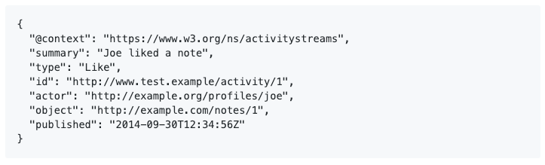

Figure 1 - Activity Example

## Implementations

Conforming implementations are software that publish, store, analyze, consume or otherwise process conforming documents. The two main kinds of implementations are publishers and consumers.

A non-exhaustive list of example publishers includes:

* A social network
* A personal web sites
* A document publishing system
* A bridge from a non-conforming social network
* A document converter from similar document types such as RSS or Atom

A non-exhaustive list of example consumers includes:

* A social network
* A search engine
* A feed reader
* A document validator
* A feed aggregator
* A statistical analyzer

# What is W3C Web Annotation Data Model?

An annotation is a web resource which provides association of meta-information to resources. Traditionally, it's a practice among readers to underline text, highlight sections or write comments in the margins. Readers may explain their opinions via such annotations. Since authors or publishers of content cannot censor people, they can express their thoughts freely.

Web Annotation is a standard for creating similar annotations on the web content. It's standardized by the W3C Web Annotation Working Group. It reuses concepts and tools from Semantic Web. W3C web annotation data model (WADL)'s objective is to bring a general format to web annotation so that they can be interoperable.

The specification od W3C provides a specific JSON format for ease of creation and consumption of annotations. An annotation is a rooted directed graph that establishes relationships among resources. A resource can be either a body or a target. Typically, an annotation has a single body, which is a comment or other descriptive resource, and a single target that the Body is somehow "about". The Annotation likely also has additional descriptive properties.

Example Use Case: Ali has written a post that makes a comment about a particular web page. His client creates an annotation with the post as the body resource, and the web page as the target resource.

Since resources are distributed on the web, they are identified using IRI (Internationalized Resource Identifier). Users often want to select part of a resource and not the entire content at the IRI. This is called Segment (of Interest). A Selector is used to extract the segment from a resource. For example, selectors are available to select some region of an image; an exact quote; content that matches a CSS or XPath rule; some text by its start and end positions; and so on.

## Model

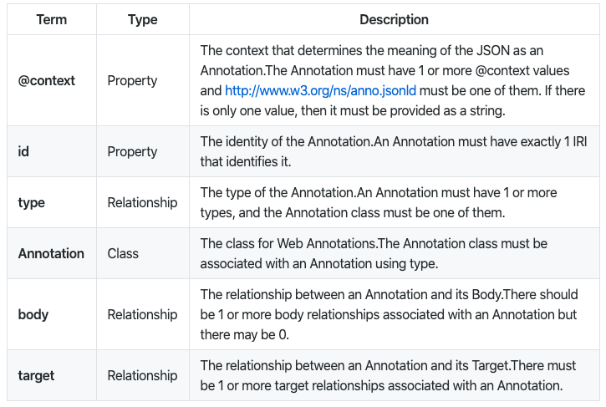

Figure 2 - Annotation Data Model

## Example of Web Annotation Models

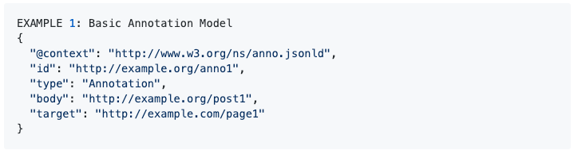

Figure 3 - Basic Annotation Model

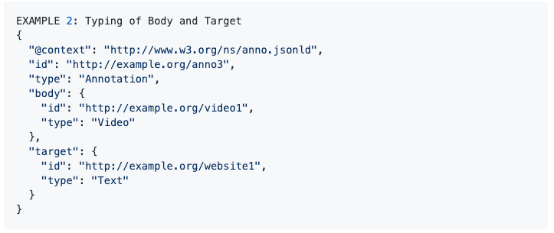

Figure 4 - Typing of Body and Target

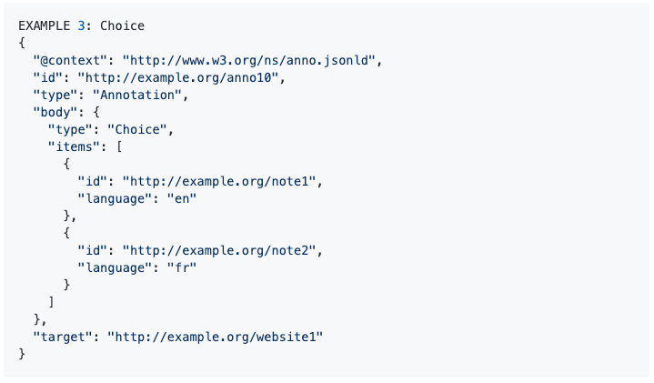

Figure 5 - Choice

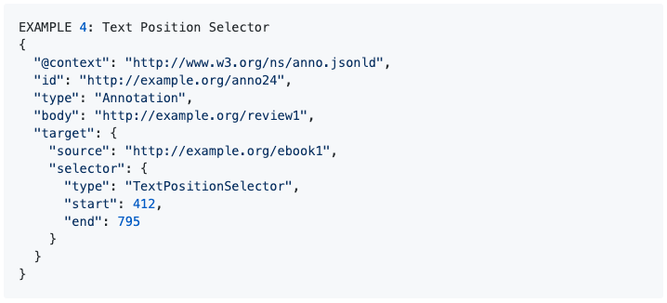

Figure 6 - Text Position Selector

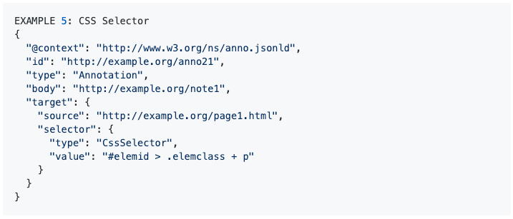

Figure 7 - CSS Selector

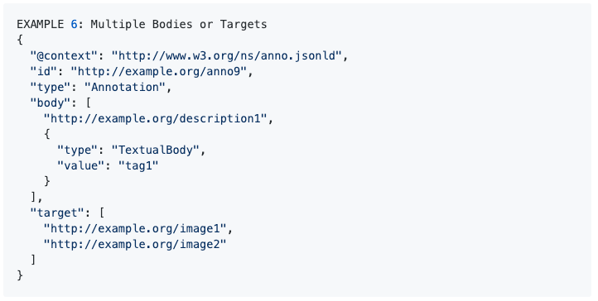

Figure 8 - Multiple Bodies or Targets

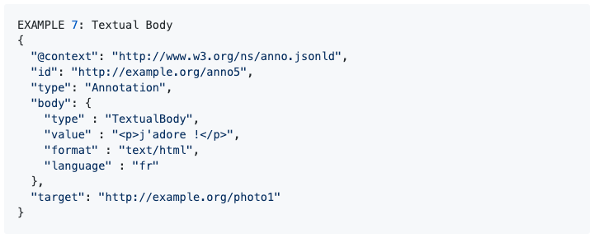

Figure 9 - Textual Body

## Related Work

Hypothesis - Annotation of the web, with anyone, anywhere.

Europeana Labs - Transform cultural heritage of europe and make it easier to use.

Apache Annotator - Provides annotation enabling code for browsers, servers, humans.

Open Annotation - Previous data model that lead to W3C WADL.

Annotorious - One such plugin for image annotation.

Pundit Annotator - Based on AngularJS and comes with open source client code which can be downloadable.

Annotator is being used in many projects: Hypothes.is, Harvard's Open Video Annotation Project, EdX, MIT's Annotation Studio, WritingPod, Crunched Book and many more.

# Technology Stack

Project is designed as a REST API. For these purpose different technologies are used together. Details can be seen below:

## Frontend

* Npm for package management
* Node as javascript engine
* React for UI/UX
* HTML and CSS for design

    

## Backend

* Gradle for dependency management
* Java for Object Oriented Programming
* Spring Boot as Web Framework

  

## Deployment

* Amazon EC2 as REDHAT machine
* Amazon RDS for PostgreSQL database

 

## Database

* PostgreSQL as Database
* Hibernate for ORM

 

## Test

* JUnit for unit testing
* Postman for endpoint tests

 

## Idea

* IntellJ IDEA for backend
* WebStorm IDEA for frontend

 

# How to Start Project in a Local Machine

Clone repository to local machine.

git clone https://github.com/altugcagri/boun-swe-574

## Database Creation

* Install PostgreSQL
* Create "POSTGRESQL" database from terminal with root user
* Or use dockerfile for Postgresql image

## How to Start Frontend

* Go in to "\boun-swe-574\frontend" folder
* npm install
* npm audit fix
* npm start

Frontend will be started in development mode locally. Bespoke web application will be opened in default browser automatically.

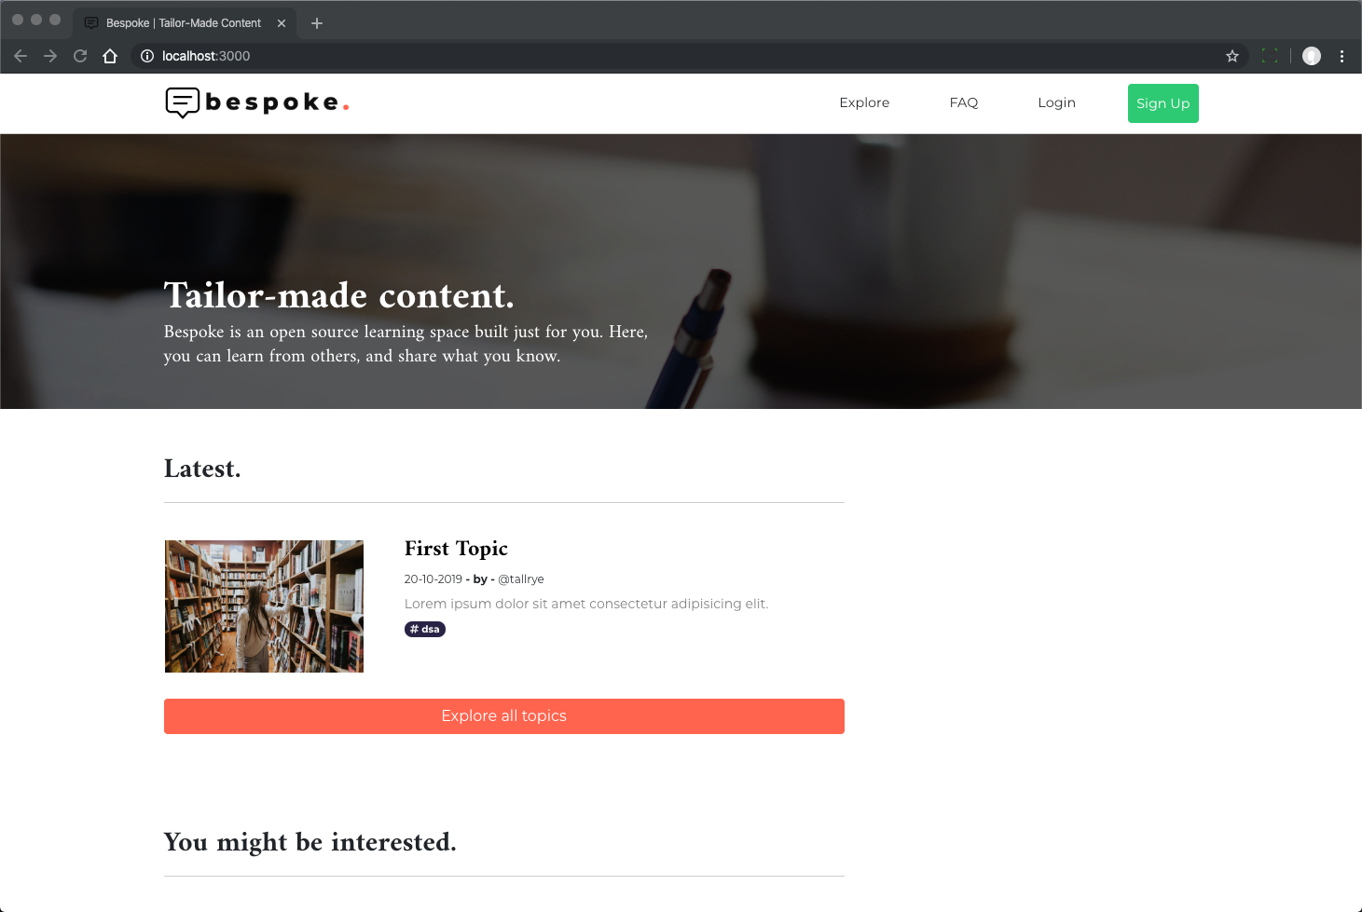

Figure 10 - bespoke in localserver

## How to Start Backend

* Open "\boun-swe-574\backend" folder with IntelliJ
* Run the application

You will see “Started BespokeApplication in …” logs.

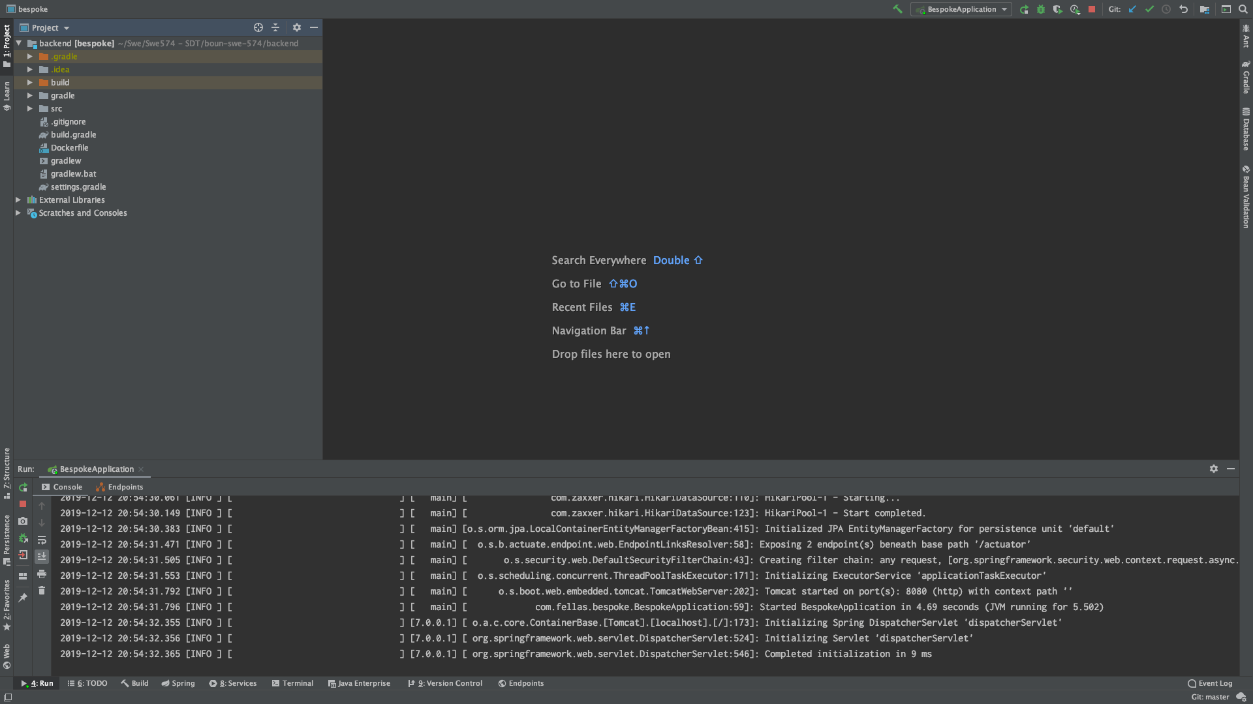

Figure 11 - bespoke backend

## How to Start Annotation Server Locally

In Bespoke, an open source annotation server project has been chosen. The name of the project is “elucidate-server”. The source code of the project and all the related information can be accessed from the following Github link. 🡪 <https://github.com/dlcs/elucidate-server>

Elucidate is a web annotation server which is complaint with W3C Web Annotation Data Model and its protocol.

### Prerequisites

* Java 8
* Apache Tomcat 8
* PostgreSQL 9.4
* Maven 3.6

### Technology Stack:

* Spring Framework
* Jackson
* JSONLD-JAVA
* JSON Schema Validator
* Liquibase

### Configuration

### In order to run Elucidate Server correctly some properties should be configured. Those are;

* **db.user** 🡪 required to authenticate database
* **db.url** 🡪 JDBC url required to connect to database
* **base.scheme** 🡪 uri scheme to be used by annotation IRIs
* **base.host** 🡪 the hostname
* **base.port** 🡪 the port number
* **base.path** 🡪 the path prefix
* **auth.token.verifierType** 🡪 whether the JWT verification key is a shared secret or an RSA public key.
* **auth.token.verifierKey** 🡪 The secret or public key used to verify signed tokens.
* **auth.token.uidProperties** 🡪 The name of the JWT property that represents a unique user ID

### Database and Security

Elucidate Server has been built and tested against PostgreSQL 9.4+

A [Liquibase](https://www.liquibase.org/) changelog contains the SQL scripts required to create the Elucidate Server schema. On first connection to a JDBC URI the changes will be applied, and a changelog table created in the database for any subsequent runs.

Elucidate Server supports user authentication and authorization using detached JWTs as credentials. Authentication can be enabled or disabled by changing the *auth.enabled* property. Those tokens can be verified using either a shared secret key or RSA public key.

### Building

There are 4 main modules in Elucidate project. Those are as follows;

* elucidate-parent
  + Parent Maven project that defines dependency library version numbers and common dependencies amongst all Elucidate projects.
* elucidate-common-lib
  + Contains common classes that are used by similar projects.
* elucidate-converter
  + Simple library that allows for conversion between a W3C Web Annotation and OA Web Annotation.
* elucidate-server
  + Main application where all the annotation creation and retrieval processes are handled with controllers and services

Each module including elucidate-server should be built using Maven using following command;

mvn clean package install -U

### Deployment

### Tomcat should be configured in the IDE.

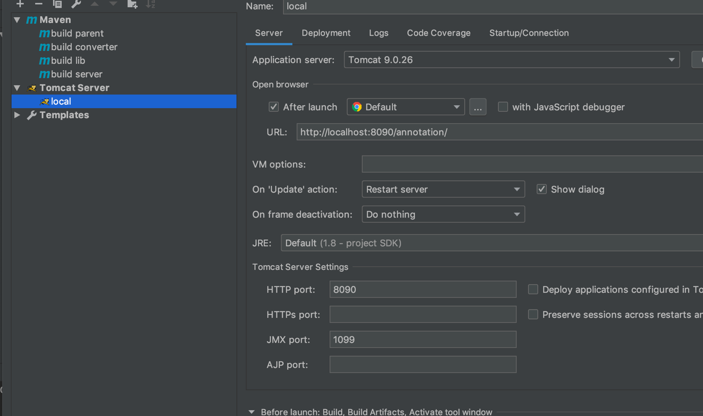

Figure 12 - Annotation Server Tomcat Configuration

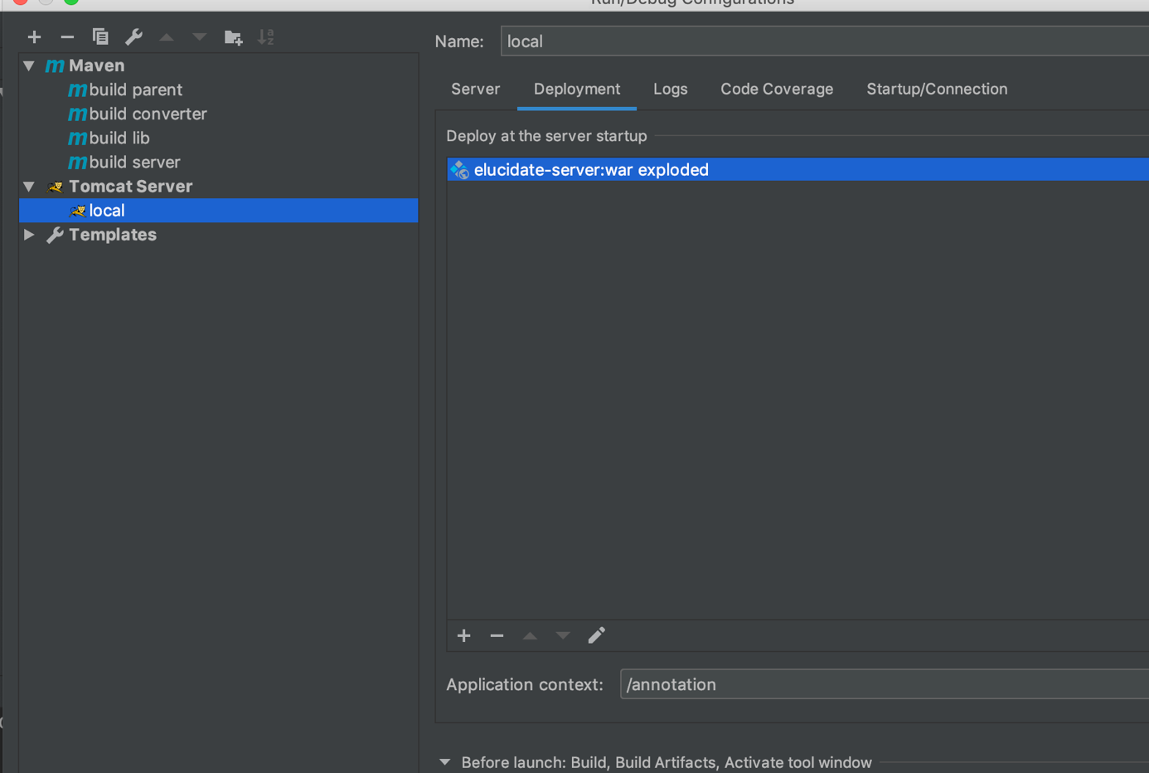

Figure 13 - Annotation Tomcat Server

After building the modules with Maven, generated war file of annotation. war can be found under target folder. The war should be selected for the deployment using Tomcat.

When project is run using this Tomcat configuration, war file will be deployed, and the application can be reached using following url:

🡪 localhost:8090/annotation/

# How to Deploy Project

## Installation

In order to install and run the backend project [Java](https://www.java.com/) Jdk v11+, [Gradle](https://gradle.org/) and [Postgresql database](https://www.postgresql.org/) must be installed.

Note that: Postgresql database is not mandatory. Any other database can be used. However database driver dependencies must be added to build.gradle file and database configurations must be added to application.properties file.

Database configuration explained below.

In order to install and run the frontend project [Node](https://nodejs.org/en/) must be installed

Set JAVA_HOME like "C:\Program Files\Java\jdk-11.0.2", "bin" folder is not required. Otherwise gradle tasks can fail.

In order to run the projects on docker environment [Docker](https://docs.docker.com/) must be installed.

After installation of Java, Gradle and Docker, you can clone the project from the [repository](https://github.com/altugcagri/boun-swe-574.git) into your workspace.

## Build BackEnd

After cloning the project go to workspace and run the gradle command:

$ .\backend\gradle build

in order to run tests, run the gradle command:

$ .\backend\gradle test

Builds the backend for production to the backend/build/libs/folder as com.fellas.bespoke-0.0.1-SNAPSHOT.jar.

## Database Configuration

In order to make database configurations for local environment, you should open backend\src\main\resources\applicaion-db-dev.properties file and change the parameters below. After making changes you should run the application with dev profile. Running with profiles is explaned under running the backend sections

spring.datasource.url= jdbc:postgresql://{DATABASE_URL}/{DATABASE_NAME}

spring.datasource.username= {USERNAME_NAME}

spring.datasource.password= {PASSWORD}

{DATABASE_URL} is the url of the database. it is mostly localhost:5432 for the local environments

{DATABASE_NAME} is the name of the database that you created on database server for the application. If you did not, first [create a database on the server](https://www.postgresql.org/docs/current/sql-createdatabase.html).

{USERNAME_NAME} is the username of your database.

{PASSWORD} is the password of your database.

In order to see database configurations for prod environment, you should open backend\src\main\resources\applicaion-db-prod.properties file. You should not change anything in this file. The parameters defined below should be defined as environment variable on the server. You should run the application with prod profile. Running with profiles is explaned under running the backend sections

spring.datasource.url=${DATABASE_HOST}

spring.datasource.username=${DATABASE_USER_NAME}

spring.datasource.password=${DATABASE_PASS}

${DATABASE_HOST} is the datasource url of the database. it must be defined as environment varible on the server named DATABASE_HOST. It is constracted like jdbc:postgresql://{DATABASE_URL}/{DATABASE_NAME}. If you did not create database, first [create a database on the server](https://www.postgresql.org/docs/current/sql-createdatabase.html).

{DATABASE_USER_NAME} is the username of your database. it must be defined as environment varible on the server named DATABASE_USER_NAME

${DATABASE_PASS} is the password of your database. it must be defined as environment variable on the server named DATABASE_PASS

Please see to create [environment variables](https://www.geeksforgeeks.org/environment-variables-in-linux-unix/) on the server. <https://www.geeksforgeeks.org/environment-variables-in-linux-unix/>

If you like to use another database please [see](https://docs.spring.io/spring-boot/docs/current/reference/html/boot-features-sql.html) <https://docs.spring.io/spring-boot/docs/current/reference/html/spring-boot-features.html#boot-features-sql>

## Run Without Docker

After building the project running the project requires the steps below;

### **Development environment:**

$ java -jar -Dspring.profiles.active=dev {Jar_File_Location}/com.altugcagri.smep-0.0.1-SNAPSHOT.jar

{Jar_File_Location} is the directory where you keep your jar file. Please change it according to your settings

It runs the backend project in dev profile. It means that application will read backend\src\main\resources\applicaion-db-dev.properties file for connecting to the your development database (most probably local database).

**Production environment:**

$ nohup java -jar -Dspring.profiles.active=prod {Jar_File_Location}/com.altugcagri.smep-0.0.1-SNAPSHOT.jar &

{Jar_File_Location} is the directory where you keep your jar file. Please change it according to your settings

It runs the backend project in prod profile. It means that application will read backend\src\main\resources\applicaion-db-prod.properties file for connecting to production database.

Application writes the log to nohup.out file which is placed where the jar is located.

## Build and Run with Docker

**Note That:** Docker files is constructed for production mode. You cannot run docker files in your local environment. You have to [set database environment](https://docs.docker.com/engine/reference/builder/#env) variables explained above before building image of backend and running containers.

**Build image**

$ docker build -f Dockerfile --tag={ContainerName} .

**Run Container**

$ docker run -p 8080:8080 {ContainerName}

## Running Instances

You can see all the running instances on AWS below;

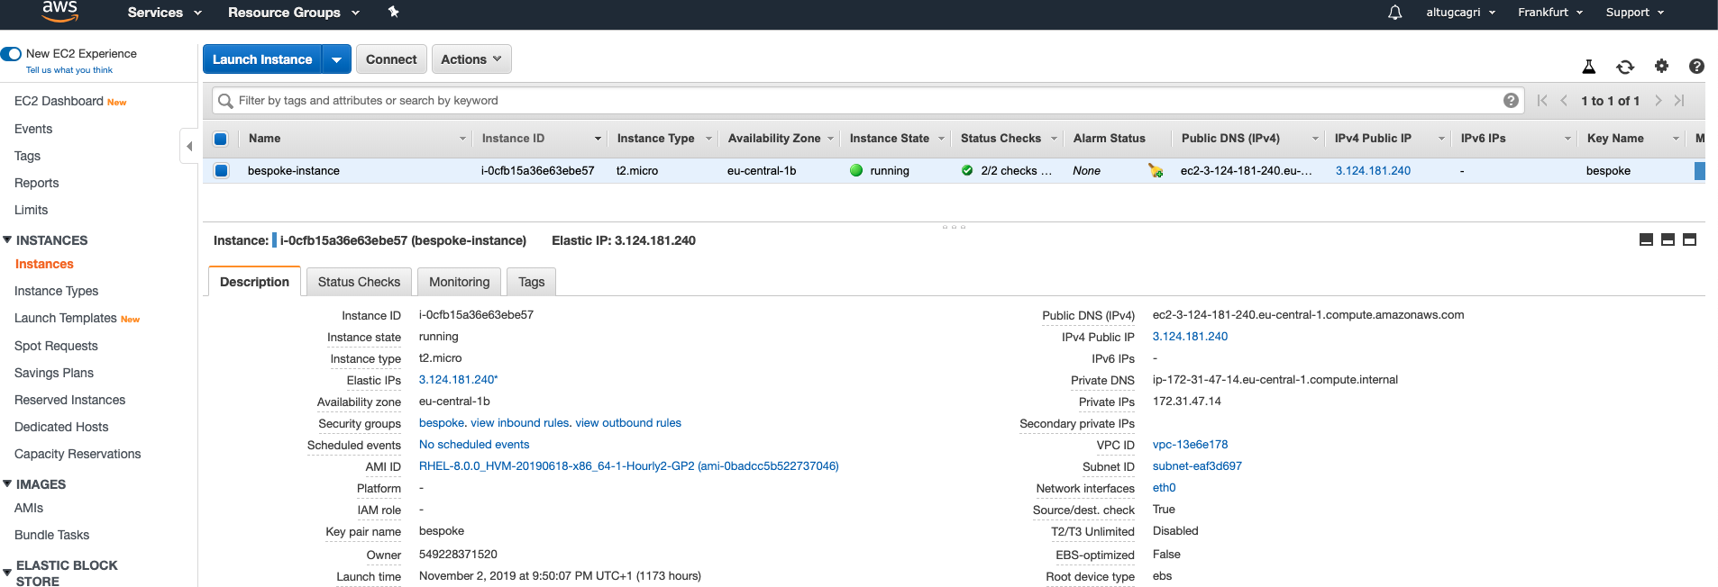

Figure 14 - AWS EC2 for Backend

Application and Annotation instance on EC2 (in the same machine)

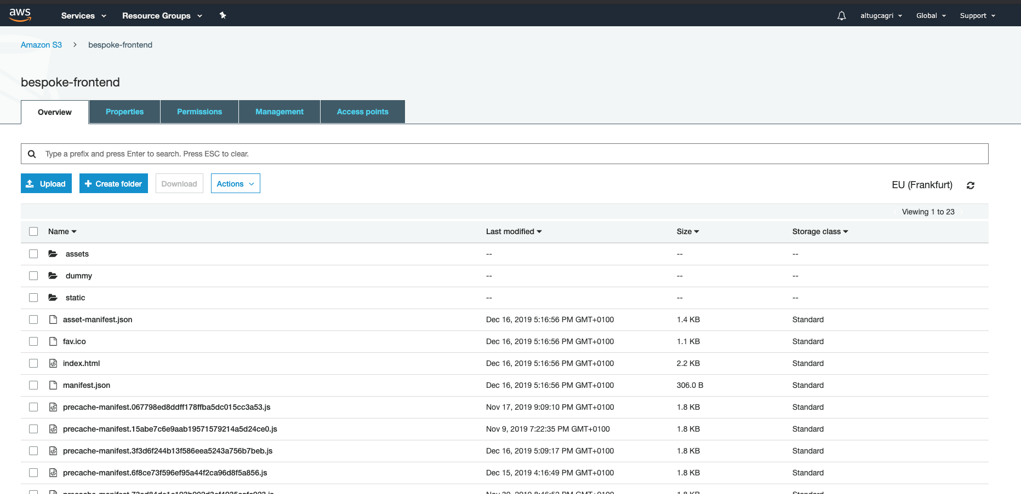

Figure 15 - AWS S3 for Frontend

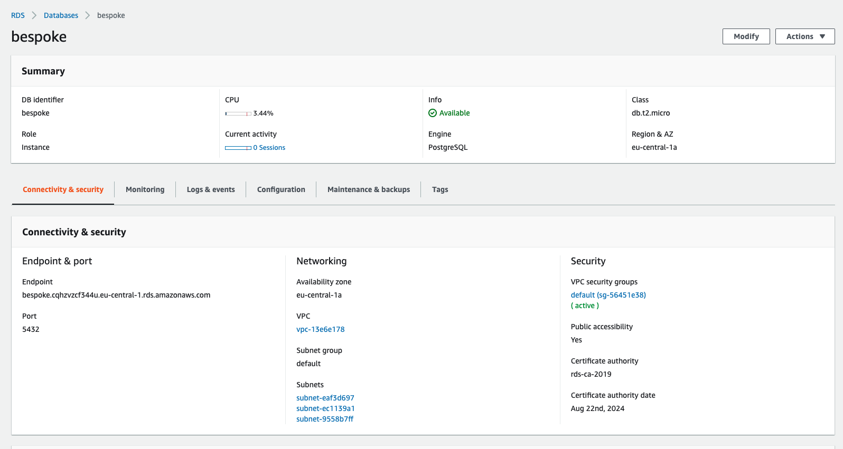

Figure 16 - AWS RDS for Database

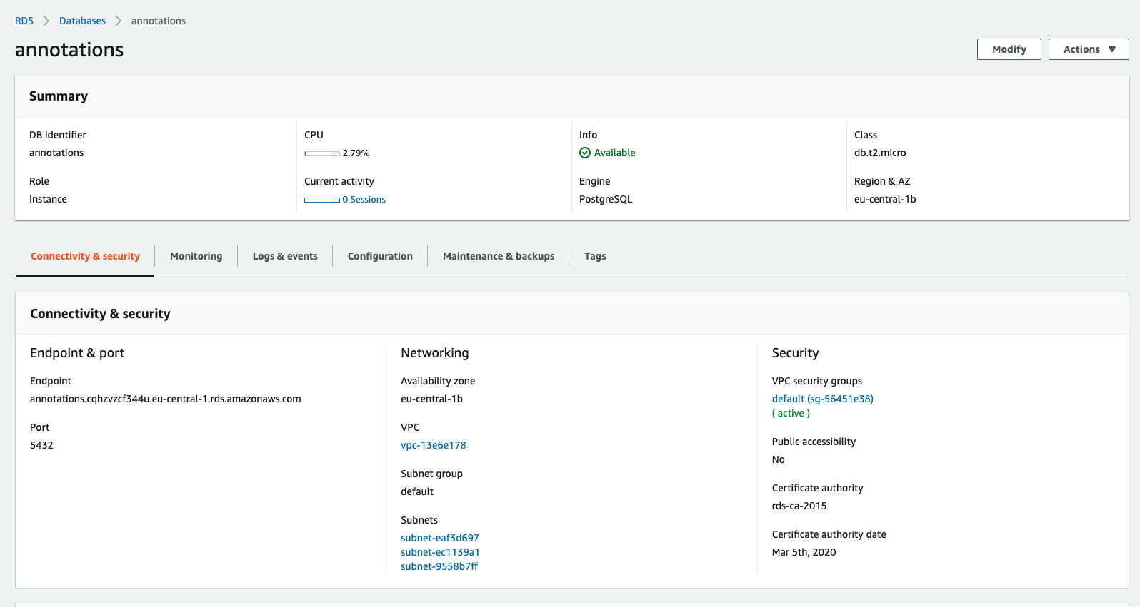

Figure 17 - Annotation Database on AWS

## Continuous Integration & Continuous Deployment

[CircleCI](https://circleci.com/docs/) is used for the continuous integration and continuous delivery. There are three pipeline integrations on the project. I created one pipeline for each branch on github. For the sonarcloud integration I used dev branch pipeline. For backend implementation I used backend-master branch pipeline. Finally, ı used the web-master branch for frontend pipeline.

**Backend Pipeline**

For the back-end pipeline there are three jobs on the workflow. In the first Job it runs the tests. If the test job gets results as success, second job starts. In the second job it runs build commands. It creates a jar file and puts it in a docker image. After that, it pushes the image to AWS repositories and starts a new container from pushed image on the AWS environment.

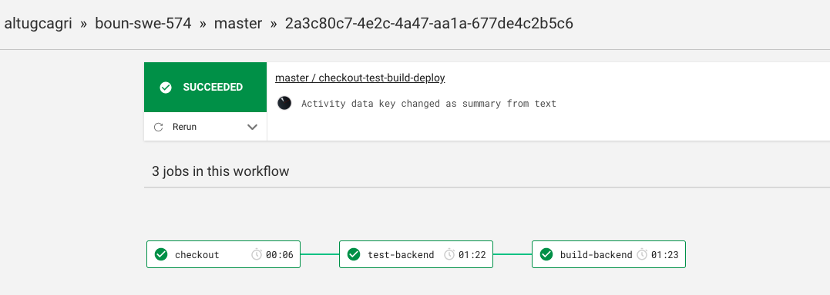

Figure 18 - Circle CI

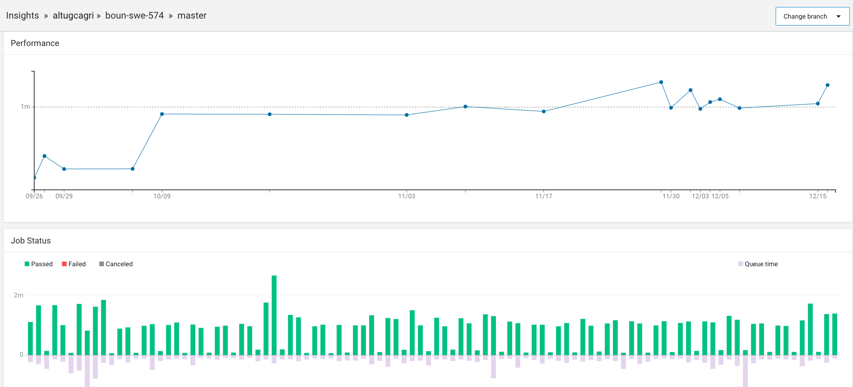

Figure 19 - Full Pipeline Report

## Static Code Analysis

Static code analysis results are listed below. According to results project is passing the quality gate with total degree A.

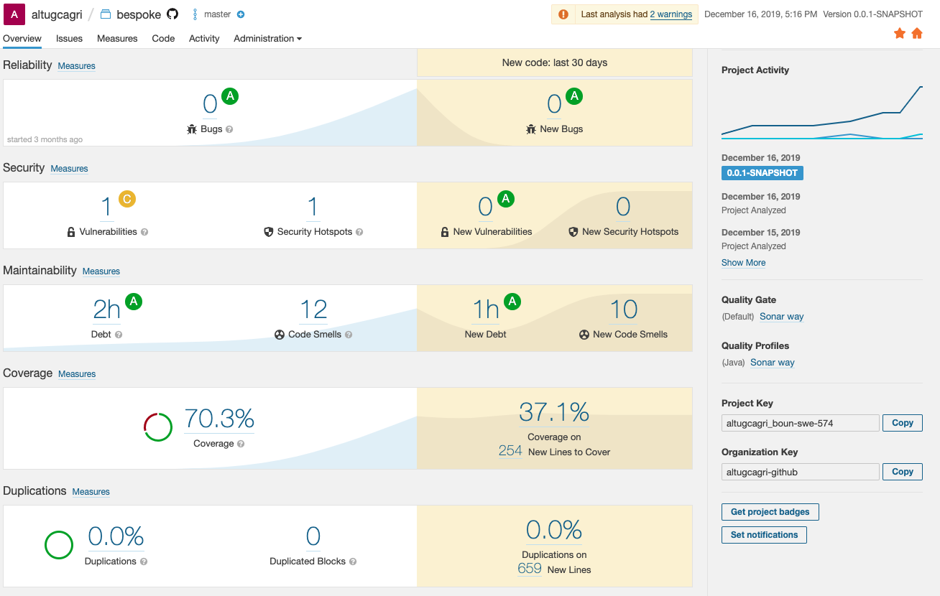

Figure 20 - Sonar Cloud

**Reliability**

According to results, there is no bug exists on the code. This makes reliability A as degree.

**Security**

According to results, there is one security vulnerability and 1 Security hot spot, which is not real vulnerability. They should be just check whether there is a potential gap or not. In the project we checked and did not see any potential gap on those hot spots. Security degree is A.

**Maintainability**

Code Smells issues are zero. Also, there is no depth issue on the code, which make maintainability degree as A.

**Code Coverage**

Unit tests are covering 70,3% of total code. There is some missing branch converge. For further improvements those branches can be covered. Despite the missing coverage, code coverage degree is A.

**Duplication**

There is no line or block duplication. This make 0 code duplication which is A.

# User Manual

On this section, we’ll briefly describe the using the Bespoke project. We’ll focus on:

* Register / Login
* Creating New Topic with WikiData
* Creating Learning Path Content
* Creating Questions
* Enroll to Topic
* Following User
* Making Annotations

## Register / Login

In order to use the Bespoke, sign-in is required. Follow the steps below described in the screenshots to create & login to your account.

**Step-1:** On the welcome screen, click on the green “Sign Up” button at the top-right corner of the page.

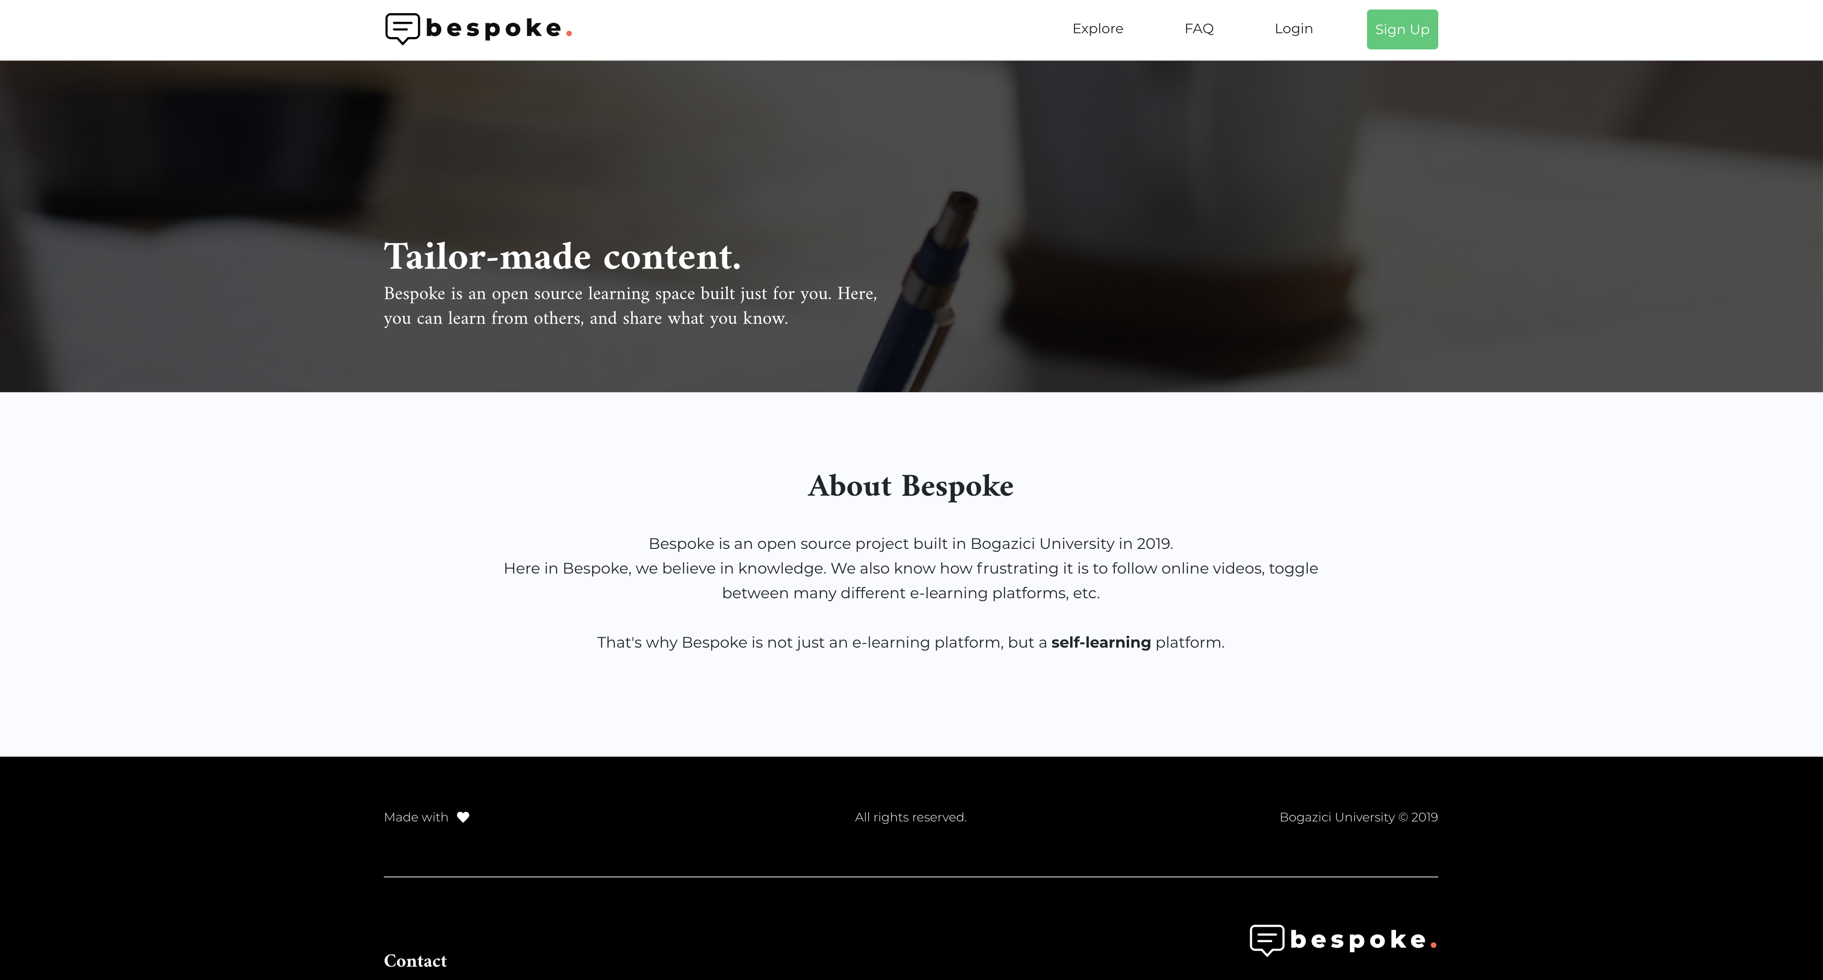

**Step-2:** Fill the form in the opened dialog with your credentials.

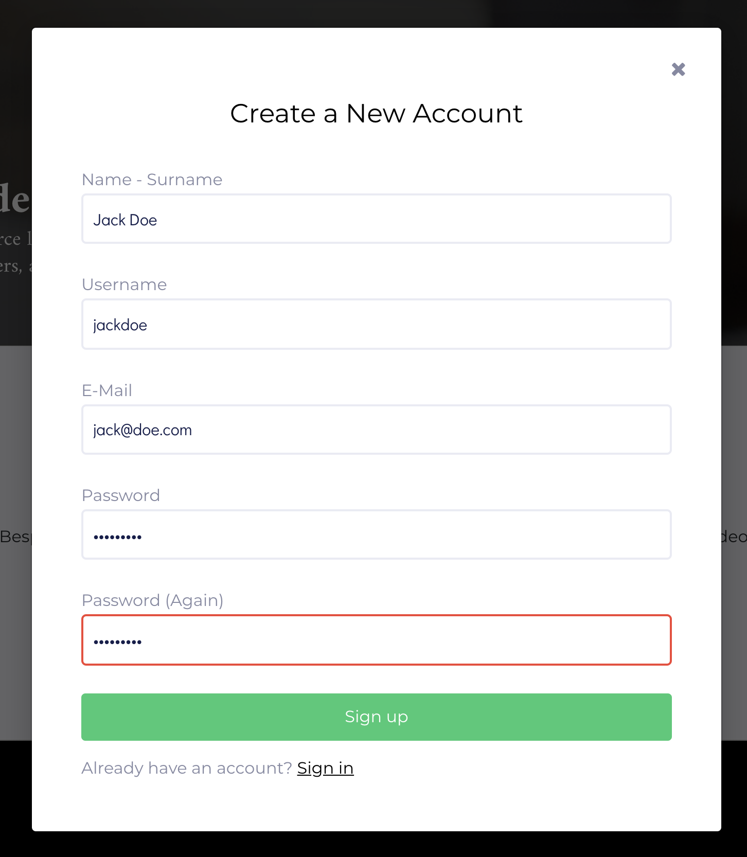

**Step-3:** Now you are ready to log in to your account with the credentials you’ve entered.

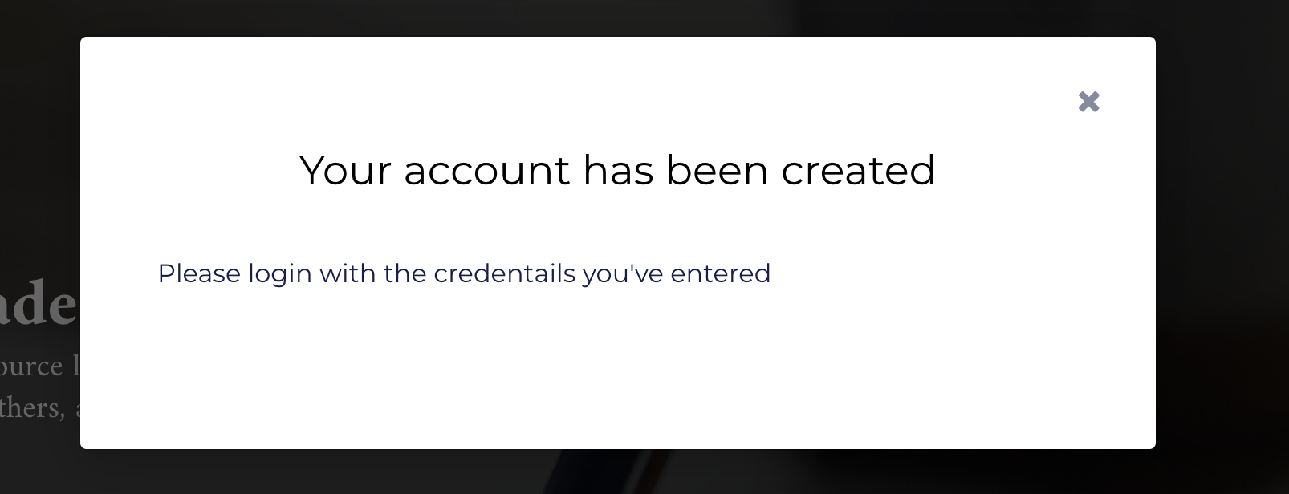

**Step-4:** On the header, click on “Login” link and provide your registered email and password to the form on the dialog.

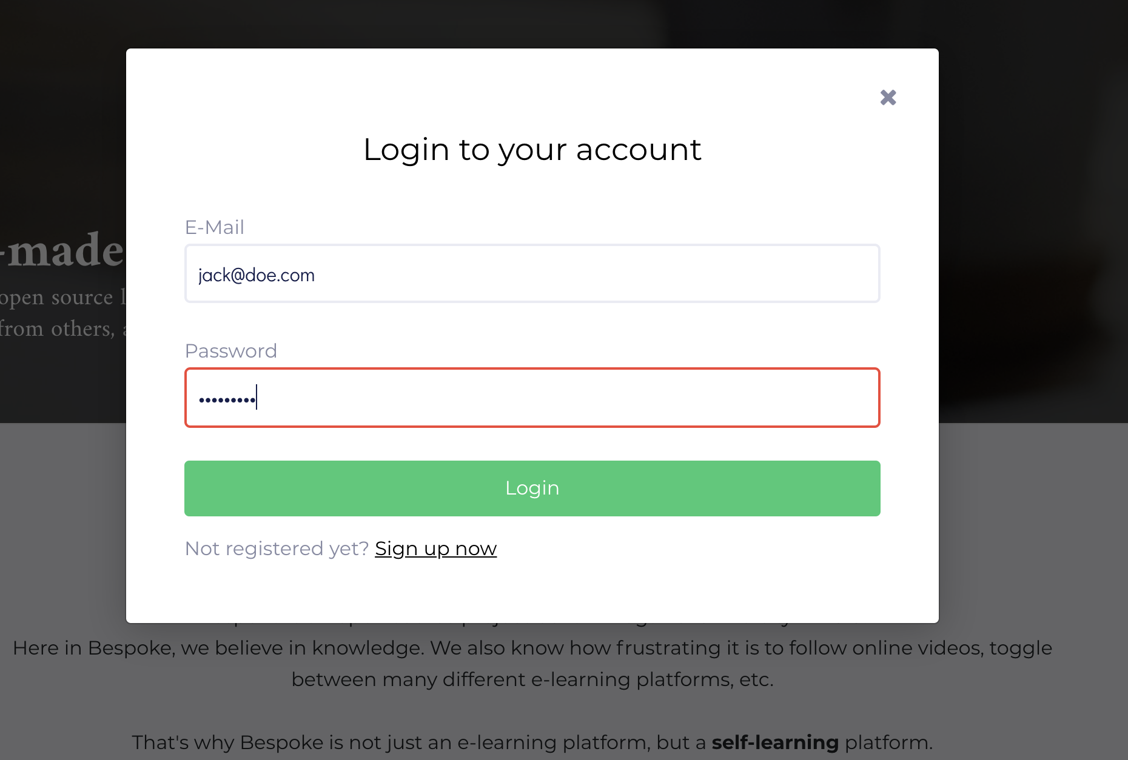

## Creating New Topic with WikiData

**Step-1:** On the header, click on the green button with your name. And on the opened dropdown, click on “My Topics”

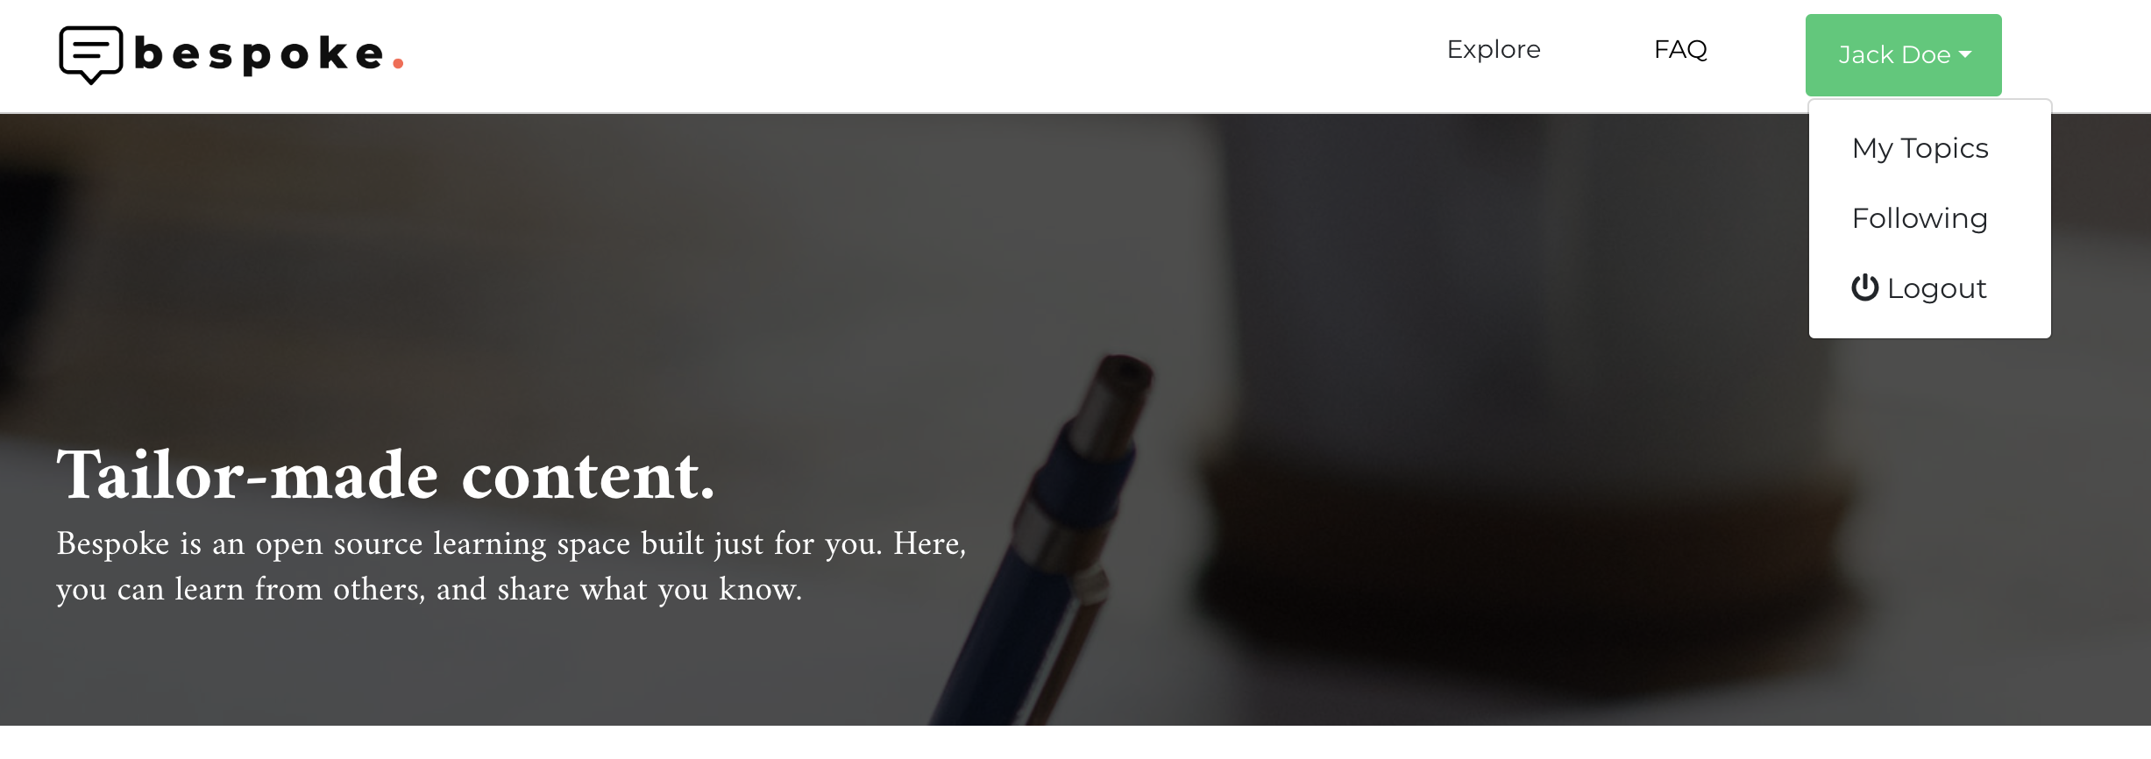

**Step-2:** On the page opened, click on “Create a Topic”

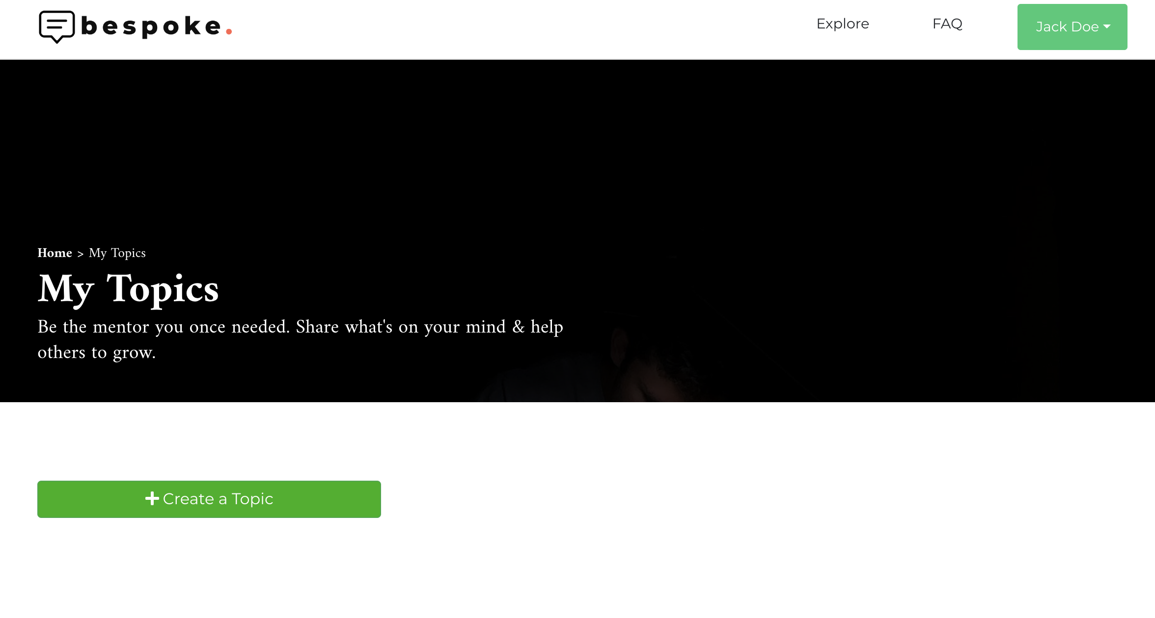

**Step-3:** Fill the topic form and search for wiki for each keyword you want to tag.

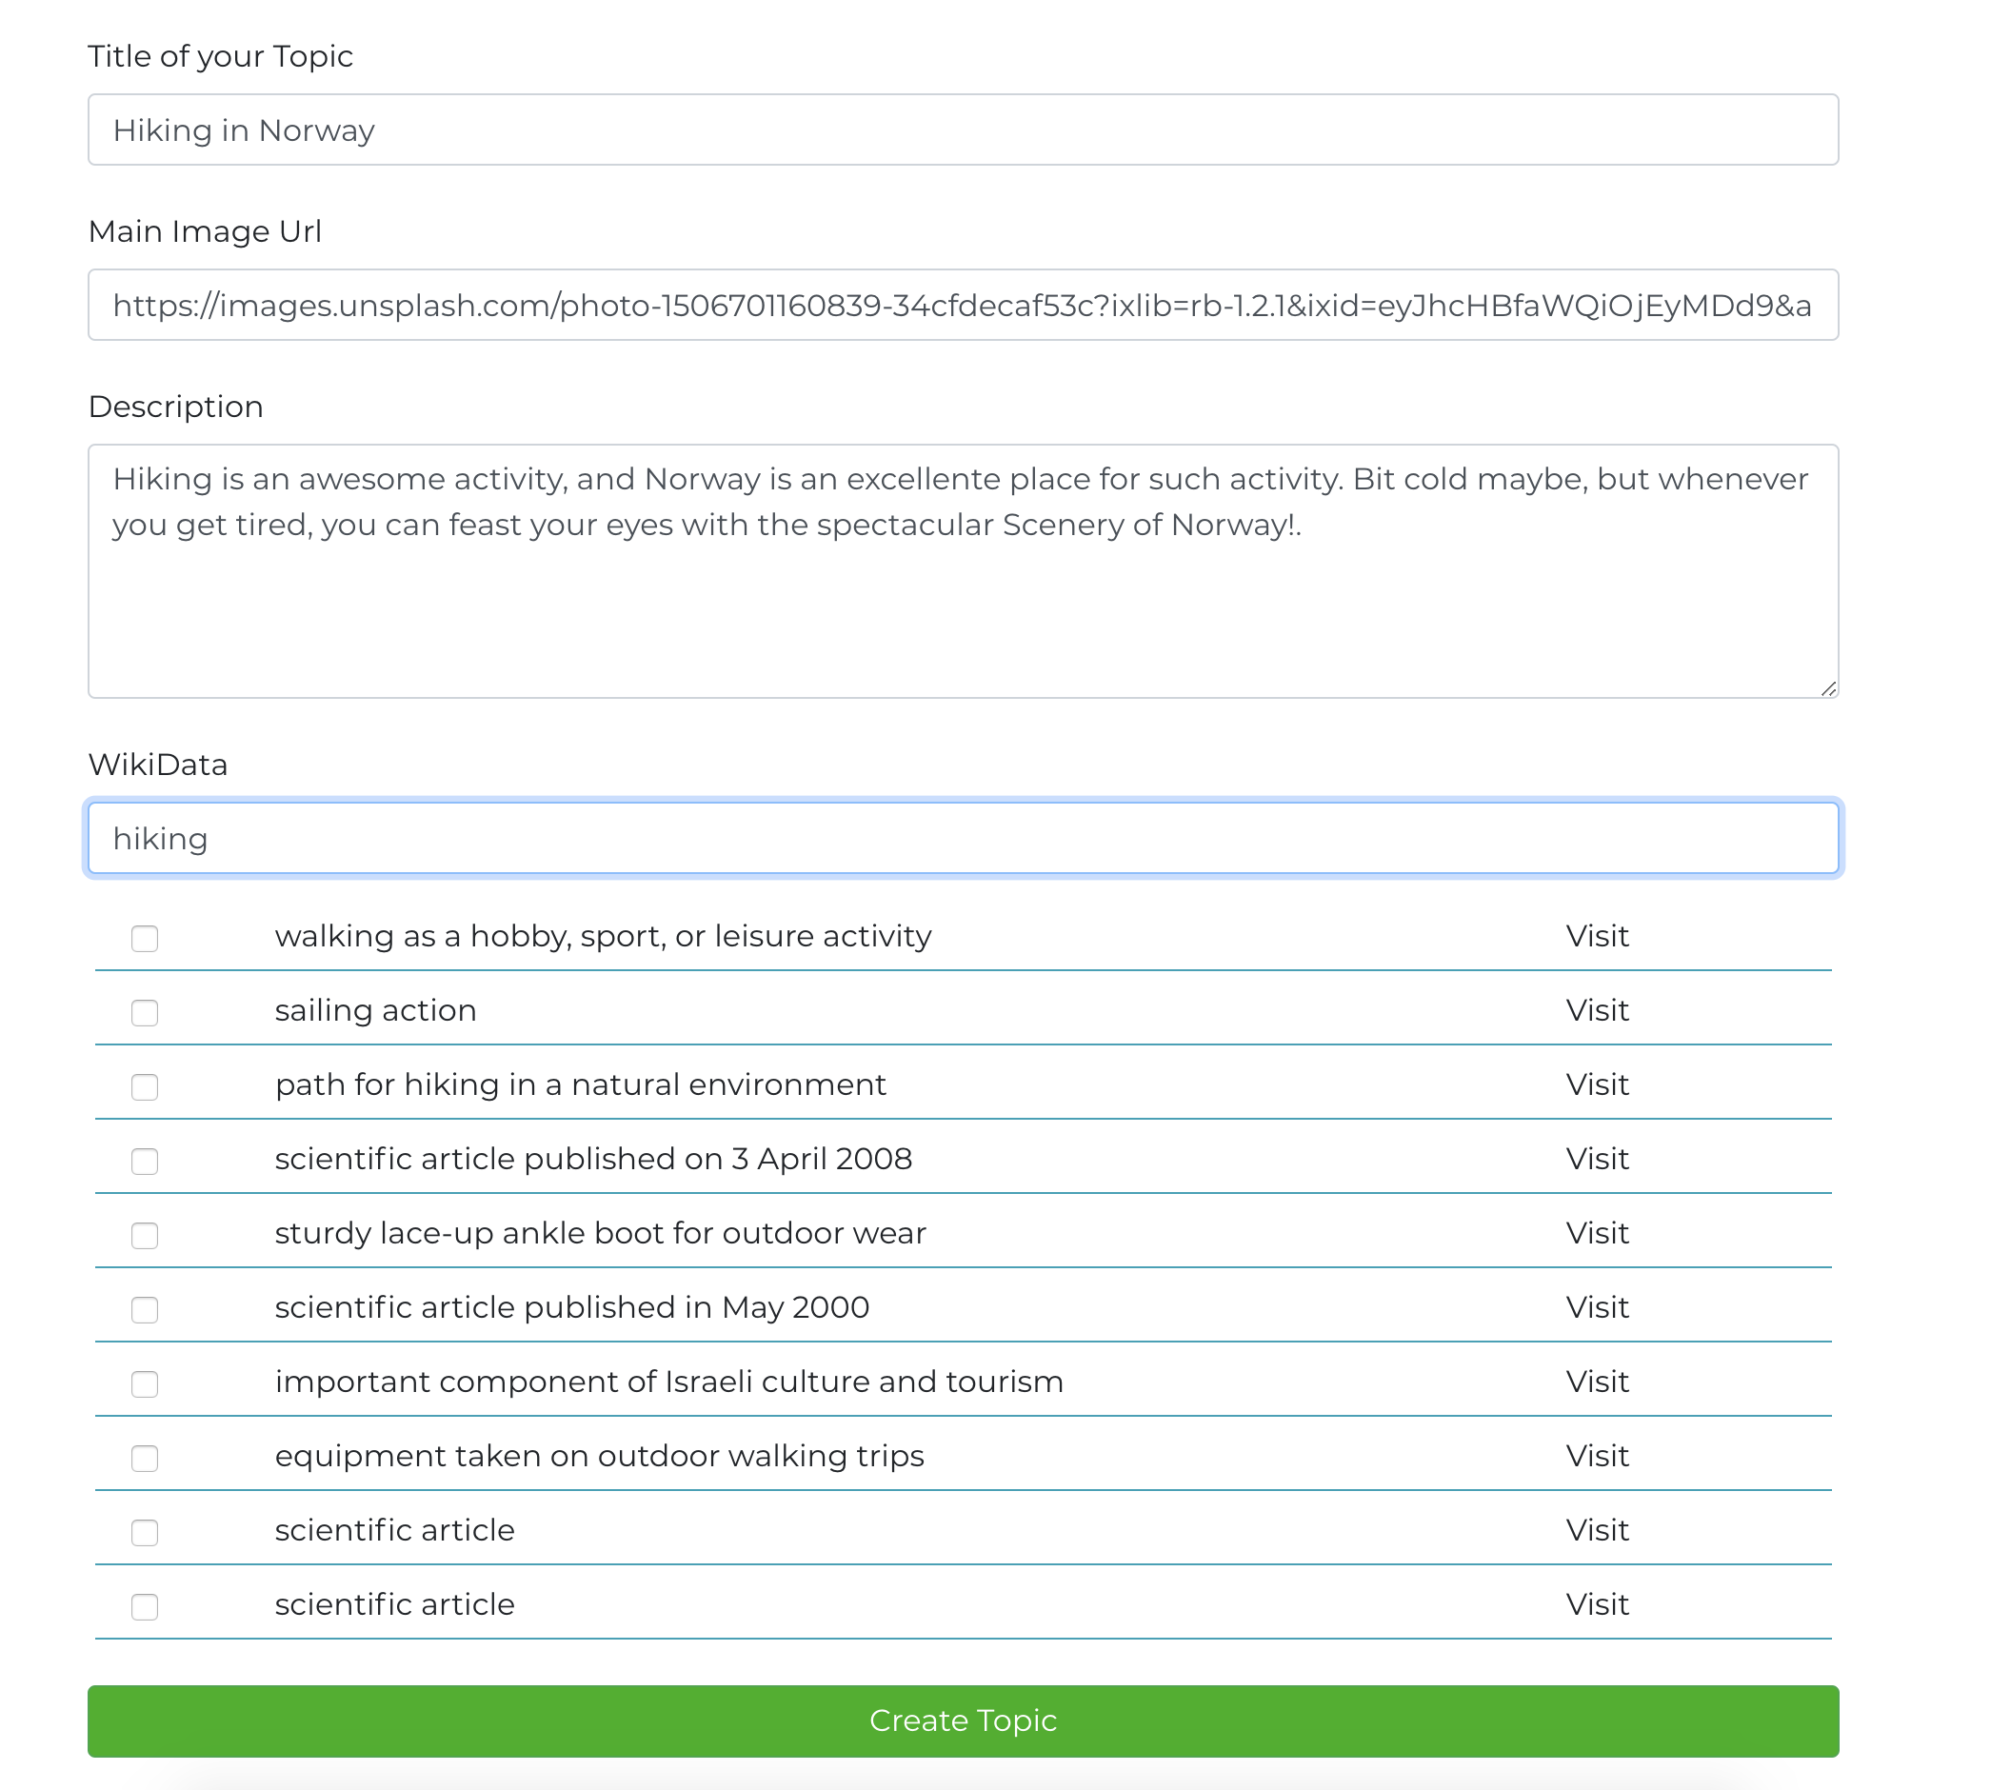

**Step-4:** Check all the wiki keywords you would like to include and search for new terms until you are done. Once you are done, click “Create Topic” and save the topic you’ve just created.

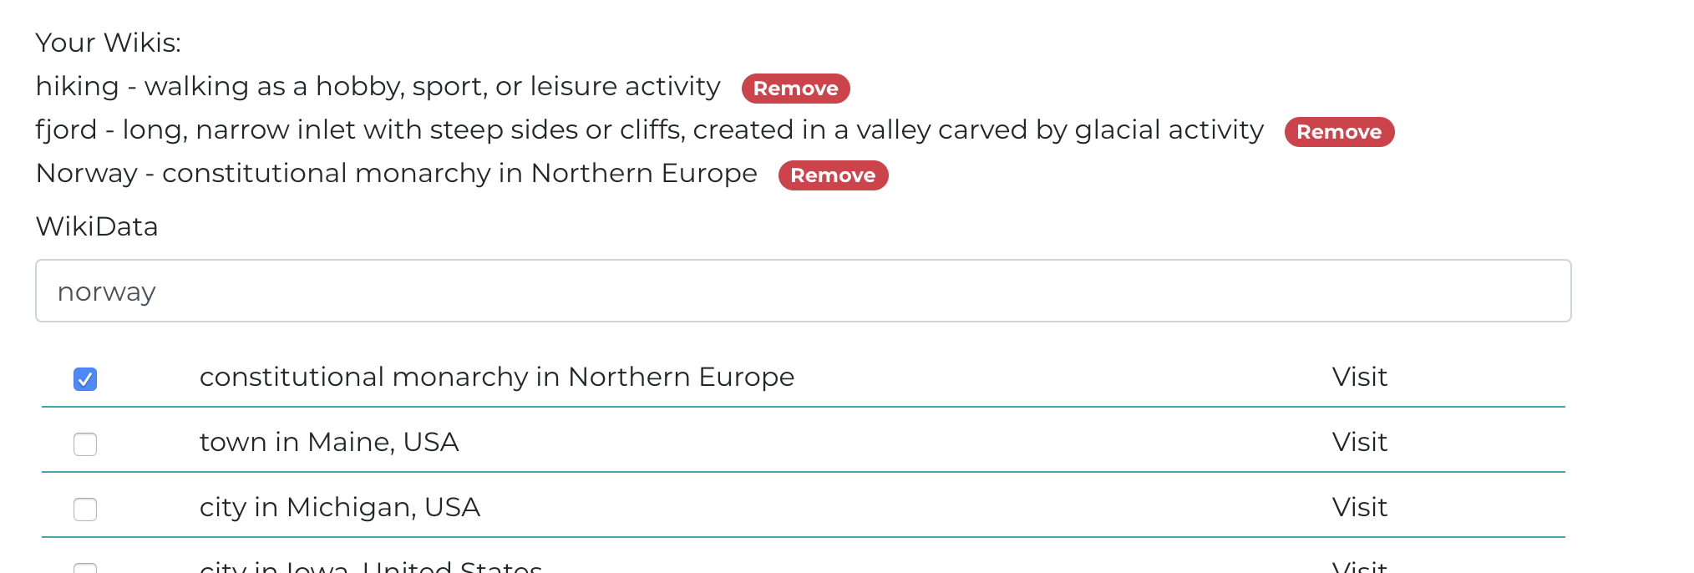

**Step-5:** Now the topic you’ve created will be visible under your topics.

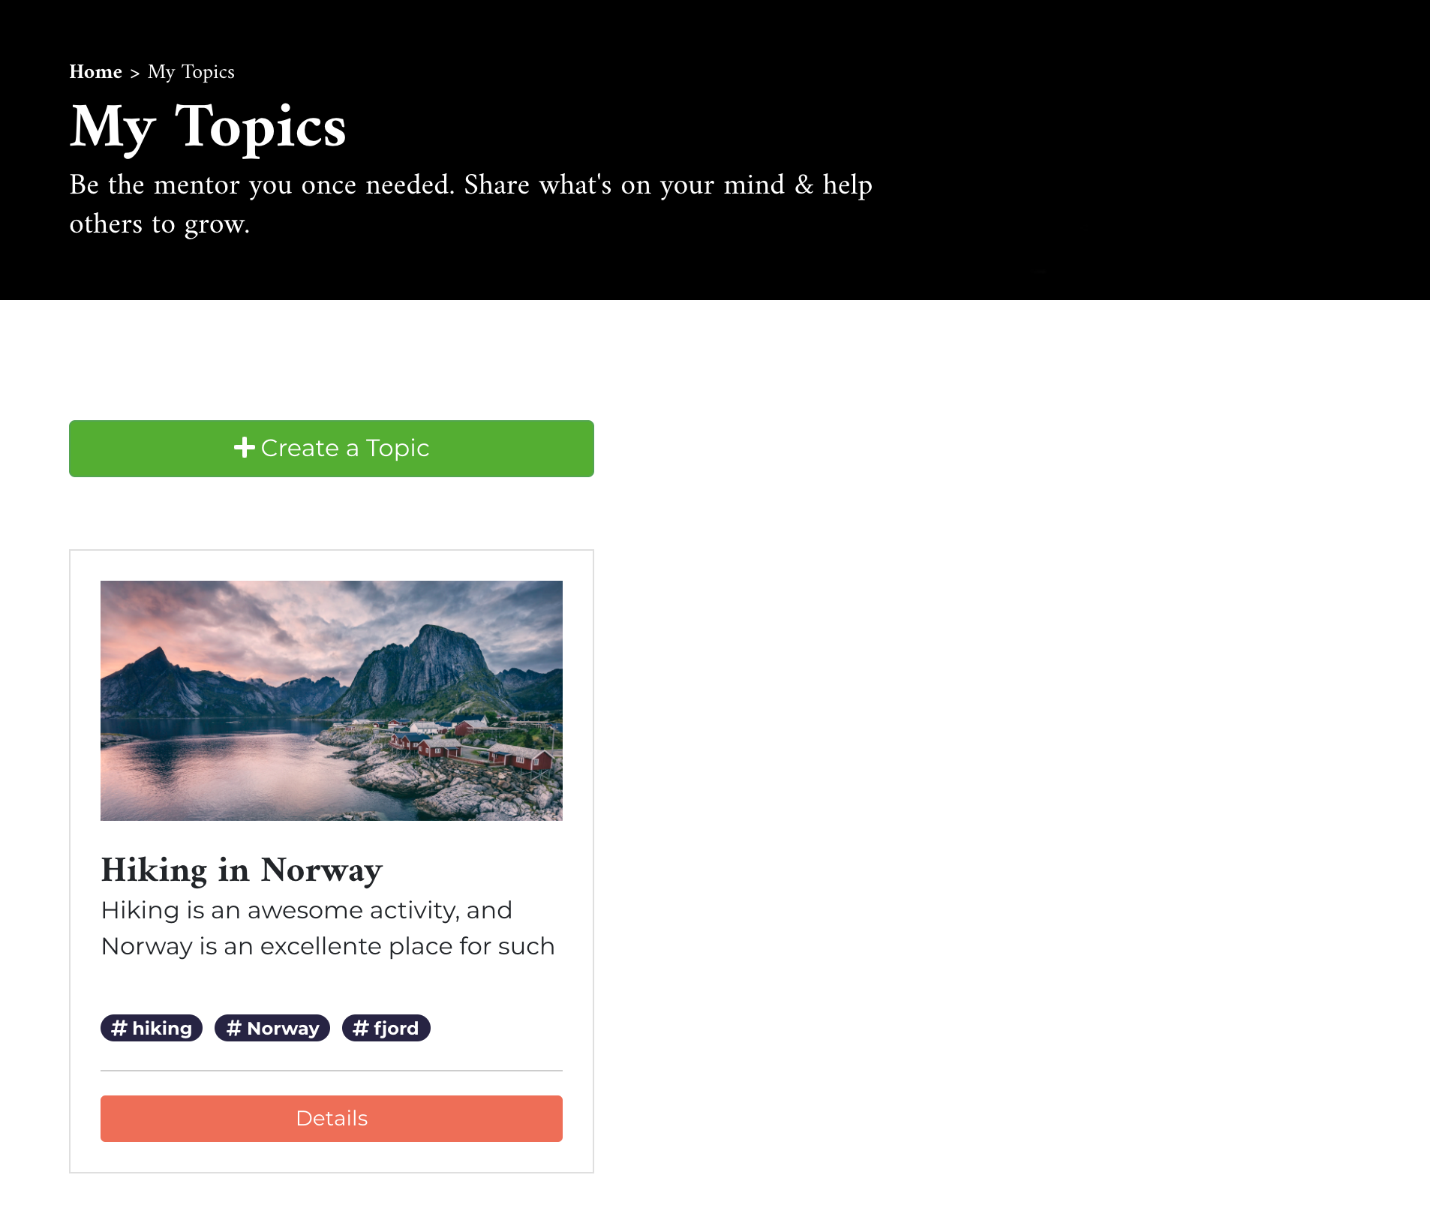

## Creating New Content

**Step-1:** Click on “Details” button on the topic-card which you want to add content to. Click on the green plus button next to the “Learning Path”

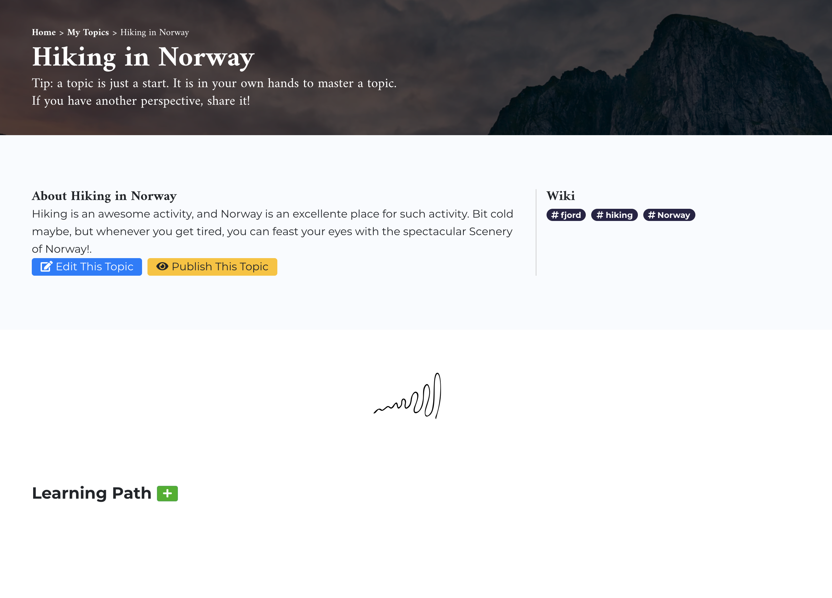

**Step-2:** Provide the information you want to share on the form and click on “Save”.

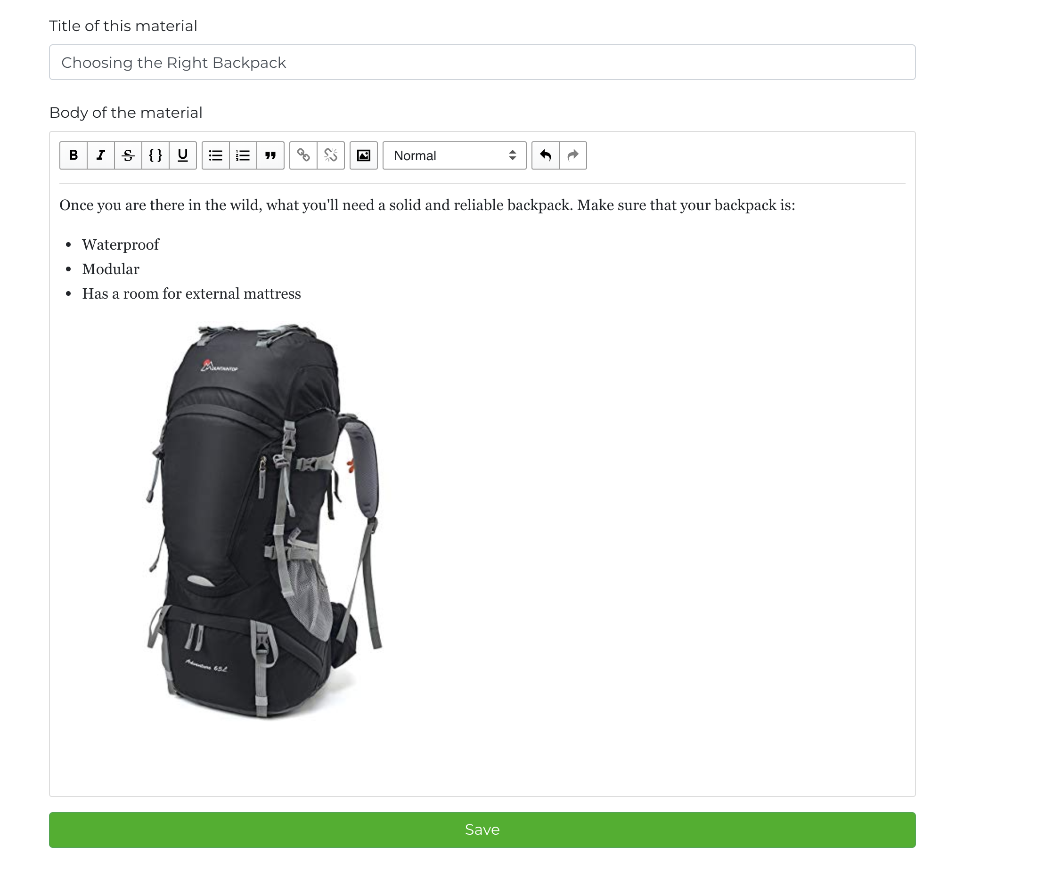

**Step-3:** Now you’ll see this content under the topic you have created.

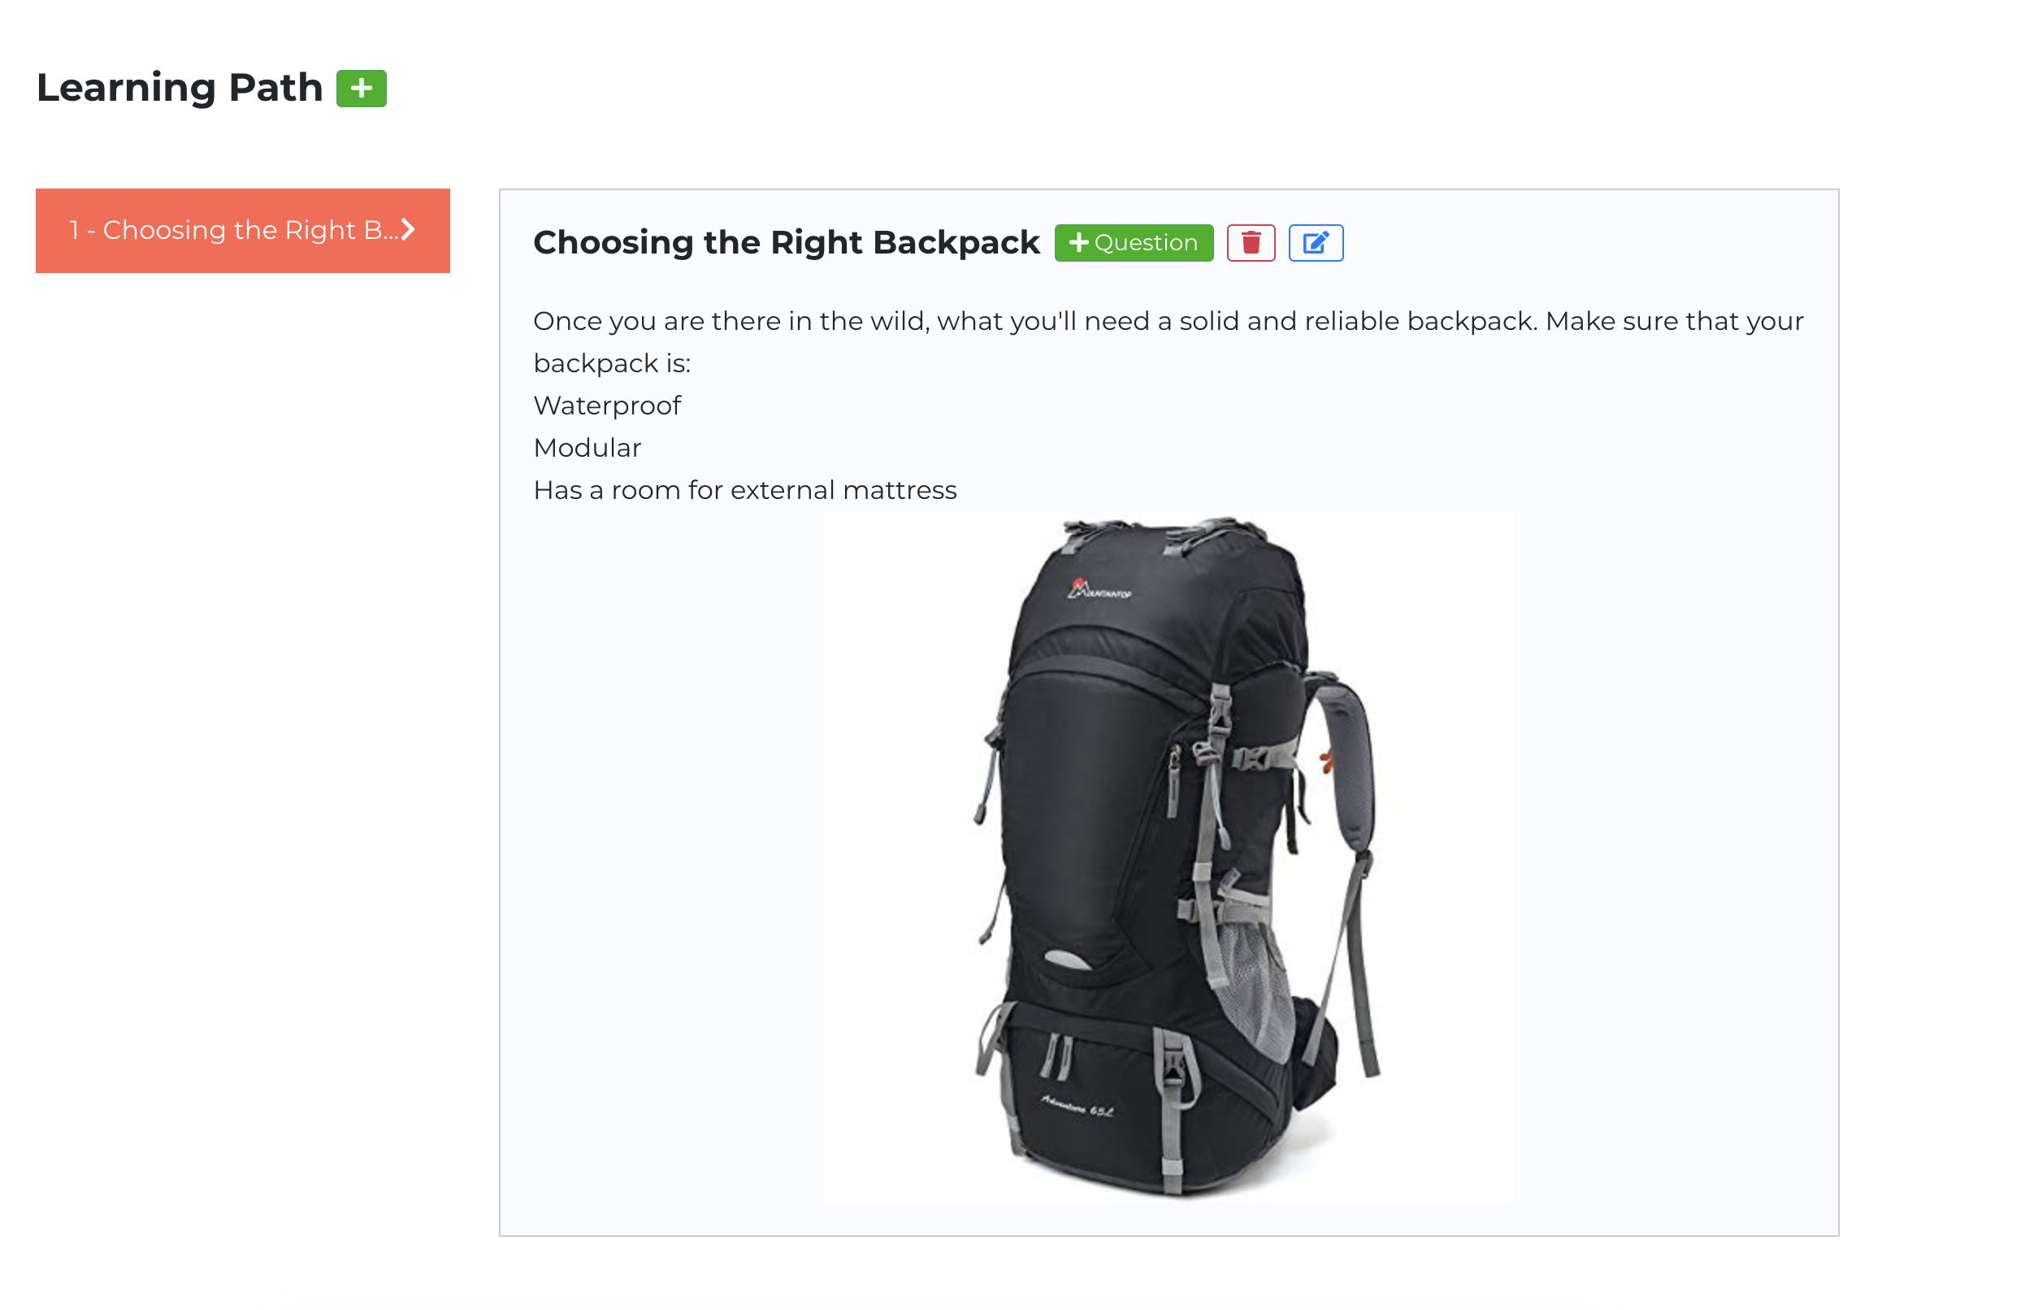

## Creating Questions

**Step-1:** You can add questions for every content. On the Topic detail page, find the content that you want to add question to, and click on the green “+ Question” button.

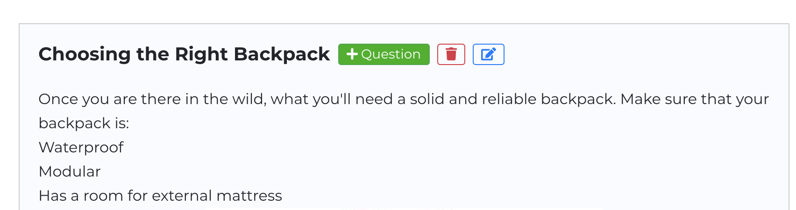

**Step-2:** On the form in the opened dialog, enter your question and click on “Save”

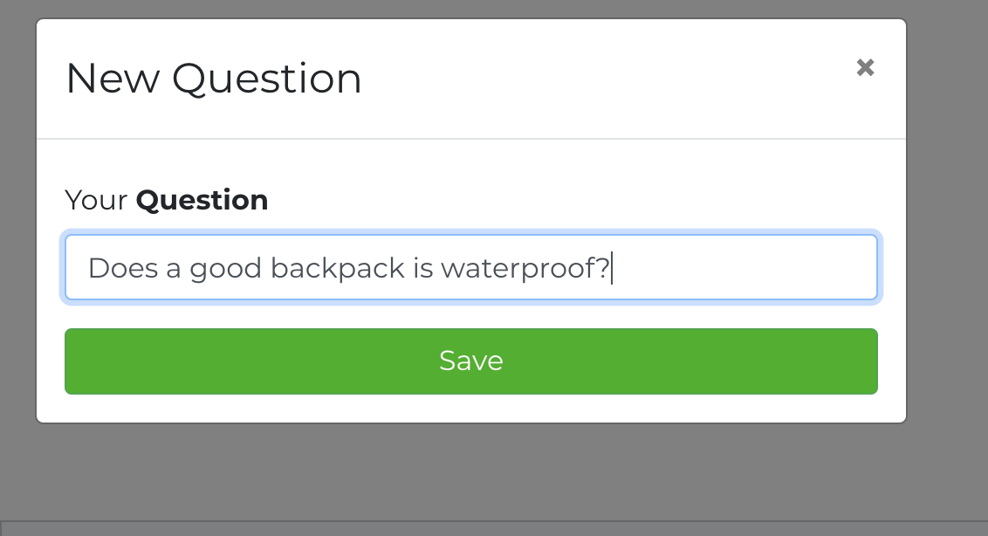

Step-3: Now your question will be visible under the content. Click on “+ Option” to add options to the question.

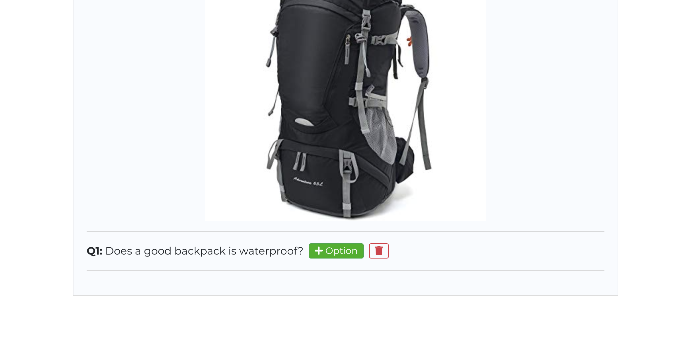

**Step-4:** Enter your option, and mark as “correct” if the option is true. You can add as many options as you want. But please add only one correct option.

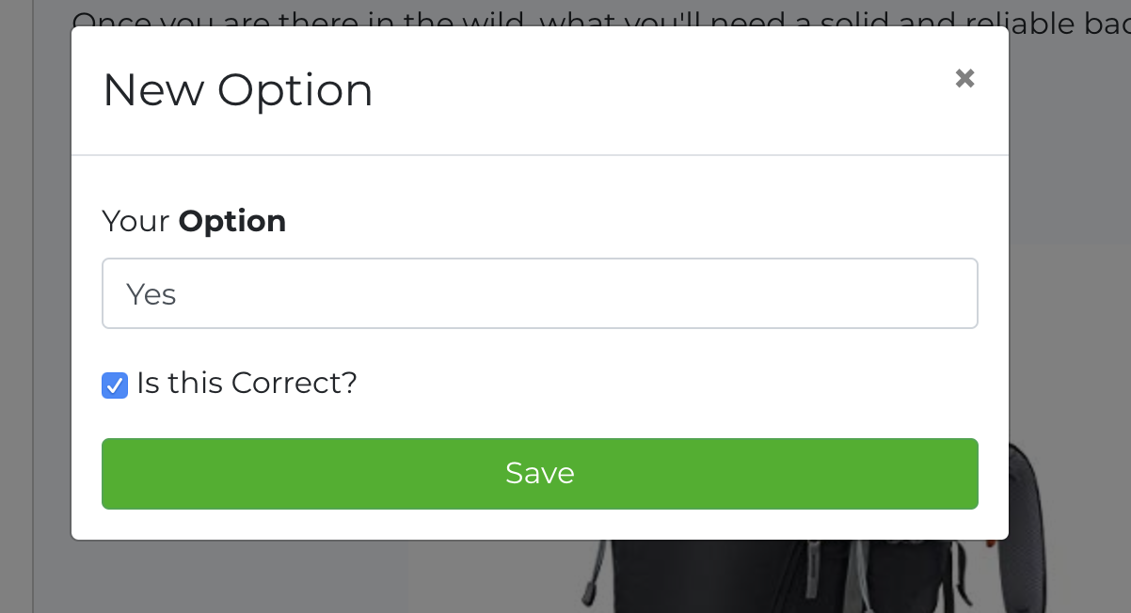

## Enroll to Topic

**Step-1**: Visit “Explore” page and find a topic that you migt be interested in.

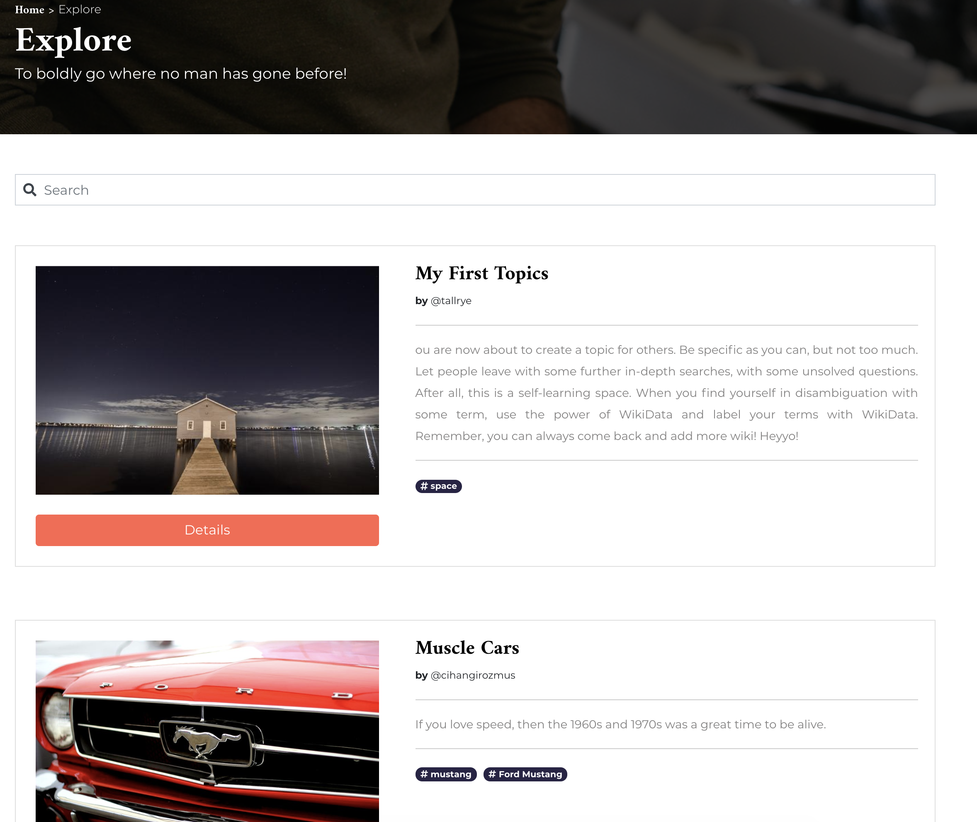

**Step-2:** Click on the topic you are interested and see the details. On this page, you can register to this topic by simply clicking on “Enroll to This Topic” button.

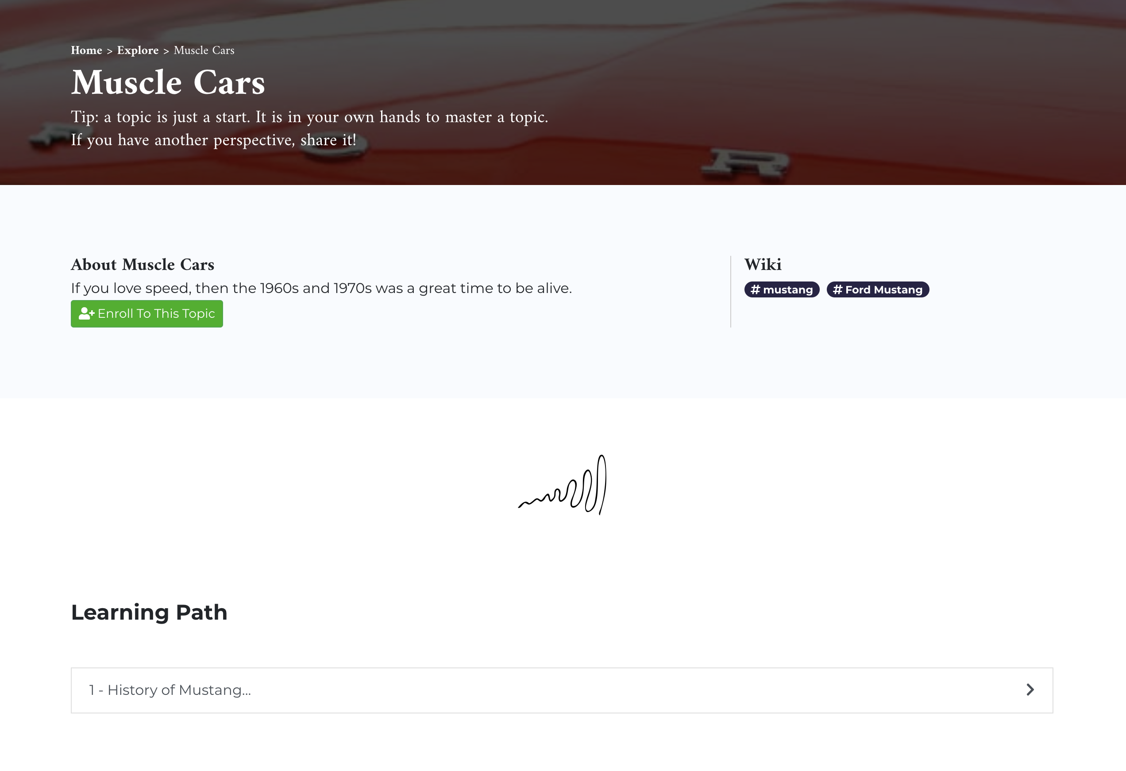

**Step-3:** Once you are enrolled to a topic, you can explore the content with the questions until you are finished with the topic.



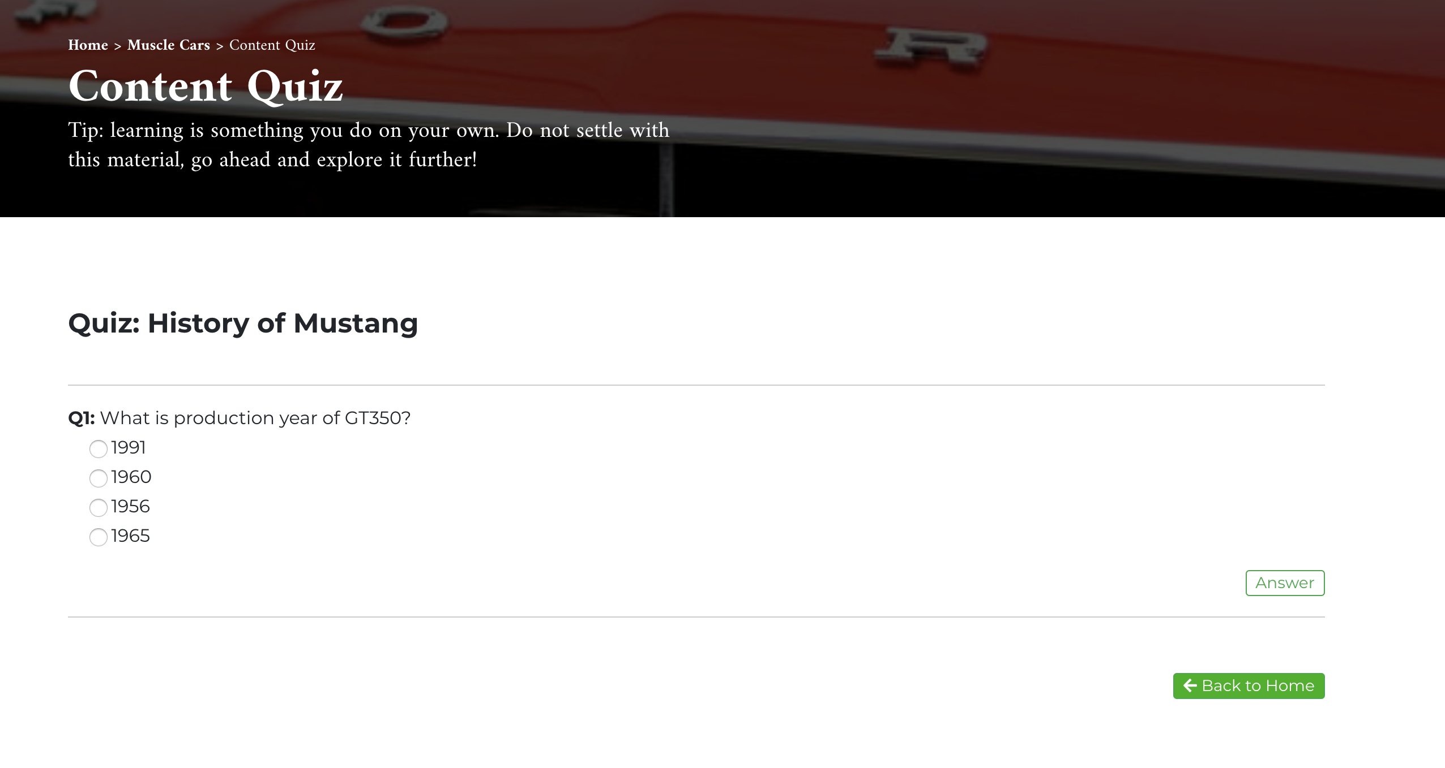

## Following a User

**Step-1:** Click on a username on the topic you’re interested in.

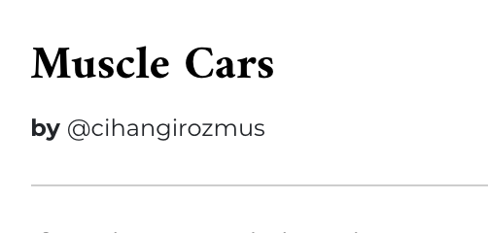

**Step-2:** Once you get to their profile, click on “Follow Username”

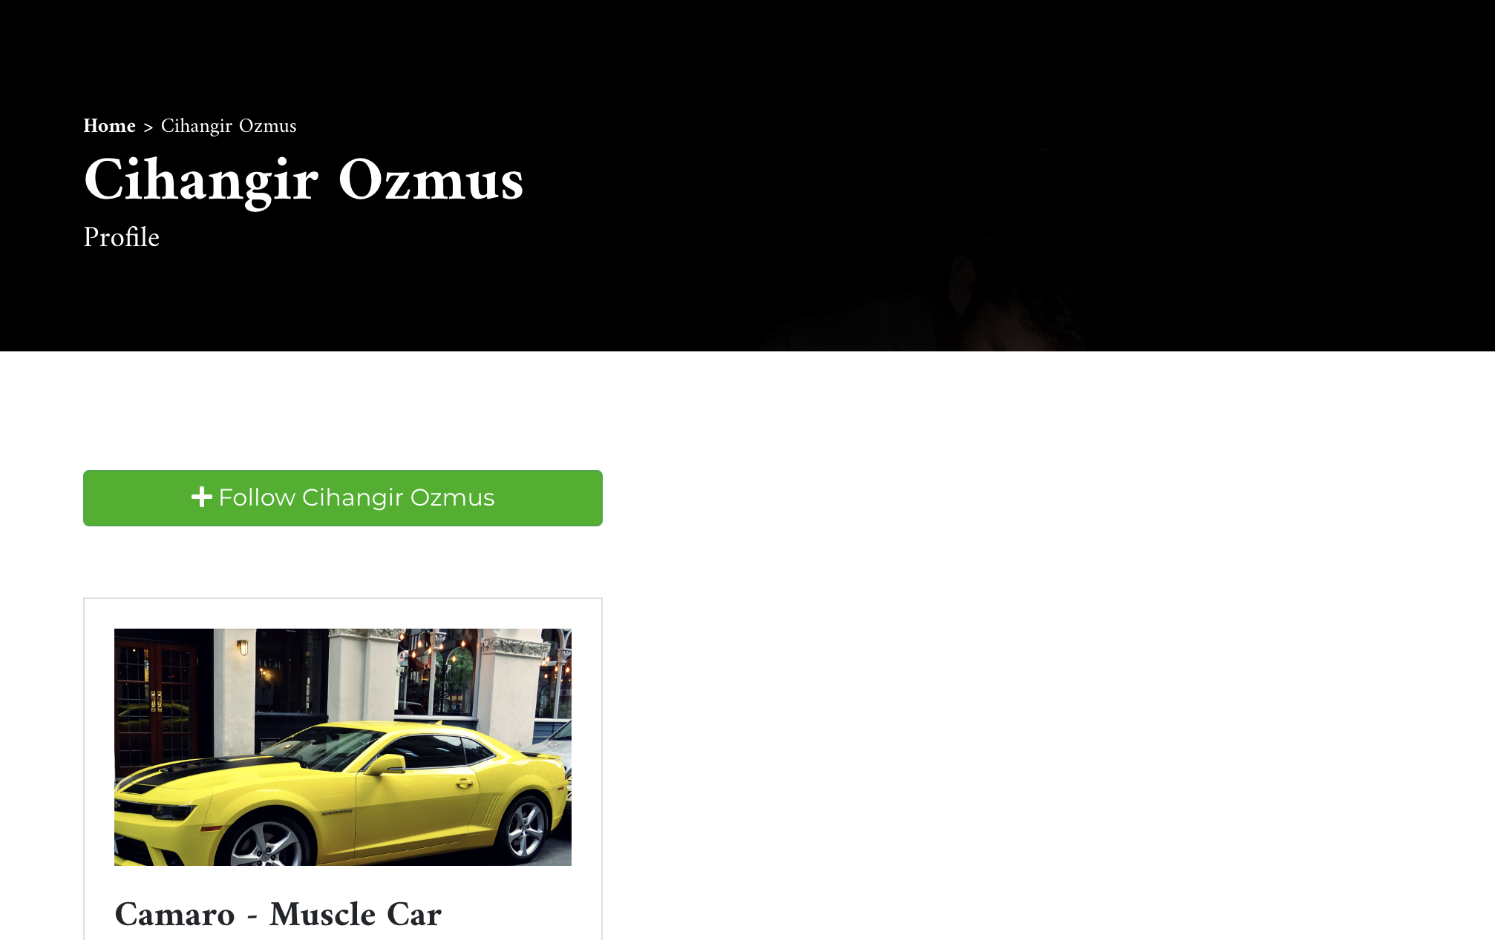

## Making Annotations

**Step-1:** Select a piece of text on the screen that you want to annotate. Once you do this, an orange button will appear on the left-side of the screen. Click on this button to create your annotation.

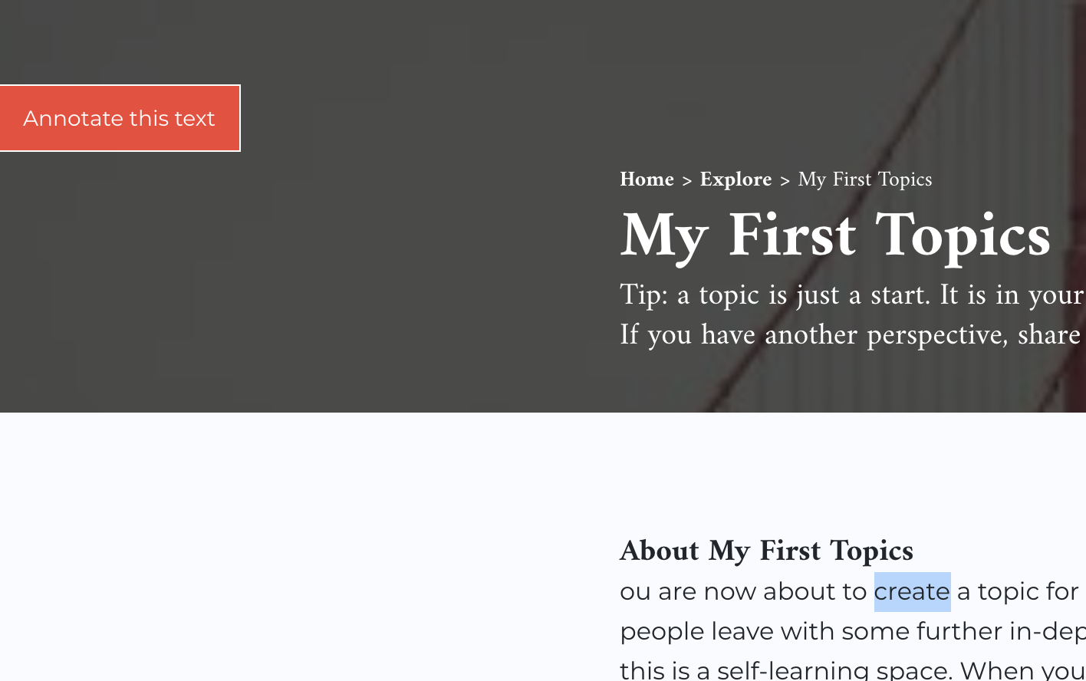

**Step-2:** Enter your comment along with your motivation and click on “Annotate”

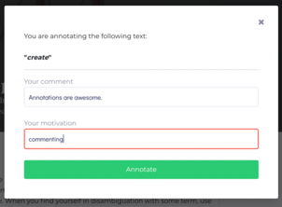

# Project Requirements

Requirement study is completed through the project description.

## Glossary

**Visitor:** A person who enters to site

**User:** Visitor who signed up and logged in

**Glossary:** List of Topics

**Topic:** Consists of topic title, topic description, topic content and label(s)

**Topic Content:** Contains topic image(s) and topic text

**Topic Statistic:** Consist of enrolled user number, accuracy of the quiz answers

**Learning Path:** A consecutive collection of topic content and related quiz

**Quiz:** A collection of questions

**Question:** Related with specific Content and created by users as a step of a Learning-Path for others to explore

**User Profile:** Consists of user email, created topic list, enrolled topic list, enrolled topic statistics

**Activity:** Action of a user defined by the W3C in https://www.w3.org/TR/activitystreams-core/

**Activity Stream:** Collection of activities defıned ın JSON-LD format

**Annotation:** A piece of comment in JSON-LD format created by a User on a page in the system related to an image or a text

**Annotation-Server:** A stand-alone, separate server that contains and serves all annotations

**Label:** Wiki tag related to content which is created by the owner of the content

## Requirements

### Non-Functional Requirements

1.1. Back-end shall use the following database system: PostgreSQL

1.2. Back-end shall be written in Java

1.3 Developed application should be deployed to web

1.4 System language shall be English

1.5 System shall have continuous integration / continuous development implementation through CircleCI

1.6 Static Code analysis shall be done through Sonar Cloud

1.7 As an acceptance criterion there should be 80 percent of code coverage on Back-end codes

1.8 System development shall be followed via Github

1.9. All Annotations should be stored in a stand-alone Annotation-Server

1.10. All Annotations should be retrieved from a stand-alone Annotation-Server

### Functional Requirements

2.1.1 Visitor shall be able to see the landing, glossary, signup and login pages.

2.1.2 Visitor and user shall be able to search glossary.

2.1.3 Visitor shall be able to sign up as a user.

2.1.4 Email and Password shall be required for sign up.

2.1.5 Email shall be unique.

2.1.6 Email and password shall be required for log in.

### Topic Requirements

2.2.1 User shall be able to create topic.

2.2.2 Topic shall have a title.

2.2.3 Topic shall have at least one tag.

2.2.4 Topic shall have a description.

2.2.5 Topic shall be seen by users.

2.2.6 Topics shall be listed in glossary.

2.2.7 Topic shall have more than one learning path.

2.2.8 Topic shall have zero or many quiz.

2.2.9 Topic statistic shall be seen by topic owner.

### API Requirements

2.3.1 User shall be able to search api with keyword(s).

2.3.2 User shall be able to select zero or many result from api search.

2.3.3 User shall use selected api result(s) in his/her topic.

### Quiz Requirements

2.4.1 Learning path shall have at least one quiz.

2.4.2 A quiz shall have at least one question.

2.4.3 Question shall be related with content.

2.4.4 Question shall have five options with only one correct answer.

### User Requirement

2.5.1 User shall be able to update the owned topic.

2.5.2 User shall be able to update the learning path which belongs to owned topic.

2.5.3 User shall be able to update the quiz which belongs to owned topic.

2.5.4 User shall be able to see quiz when the quiz is started.

2.5.5 User shall be able to continue the learning path after answering the all questions correctly.

2.5.6 User shall be able to restart the quiz.

2.5.7 User shall see his/her own user profile.

2.5.8 User statistics shall be stored with enrolled topic(s) and quiz answers.

2.5.9 User statistics shall be displayed in user profile.

2.5.10 Users should be able to follow another Users

2.5.11 Users should be able to follow Labels

### Activity Requirements

2.6.1 Users should be able to see the Activities of the Users which they are following

2.6.2 Activity Streams should be generated by the system.

### Annotation Requirements

2.7.1 Users should be able to create an Annotation for an image on a page

2.7.2 Users should be able to create an Annotation for a selected text on a page

2.7.3 Users should be able to see all the Annotations created on a page in the platform

### Recommendation System

2.8.1 Users should be able to see Recommendations based on the Labels and Users that they are following

# Sequence Diagrams

## Create Annotation

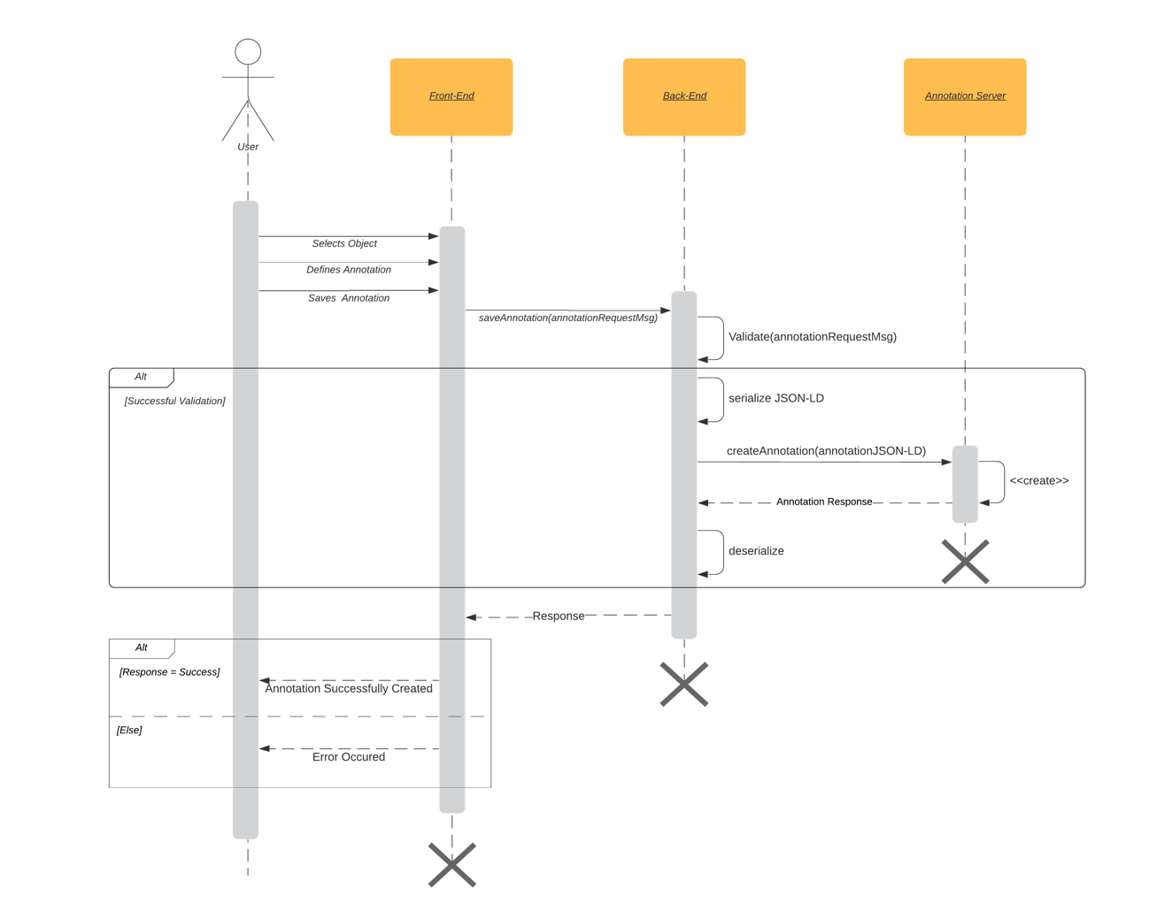

Figure 21 - Sequence Diagram for Create Annotation

## Get Annotations

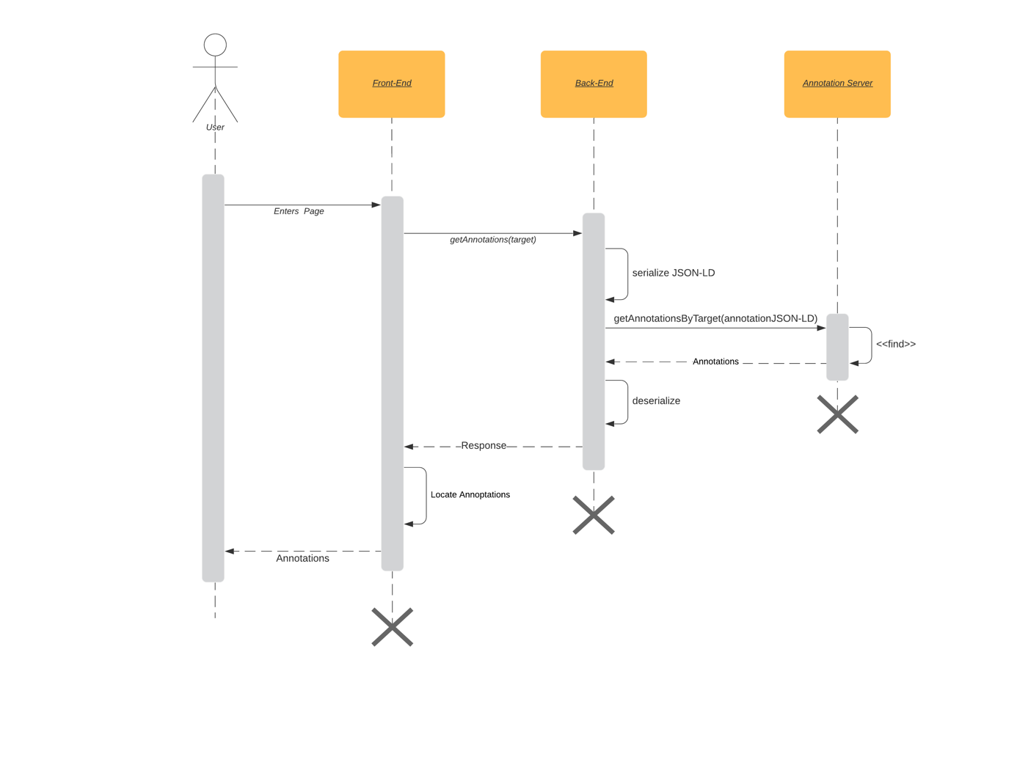

Figure 22 - Sequence Diagram for Get Annotations

## Delete Annotation

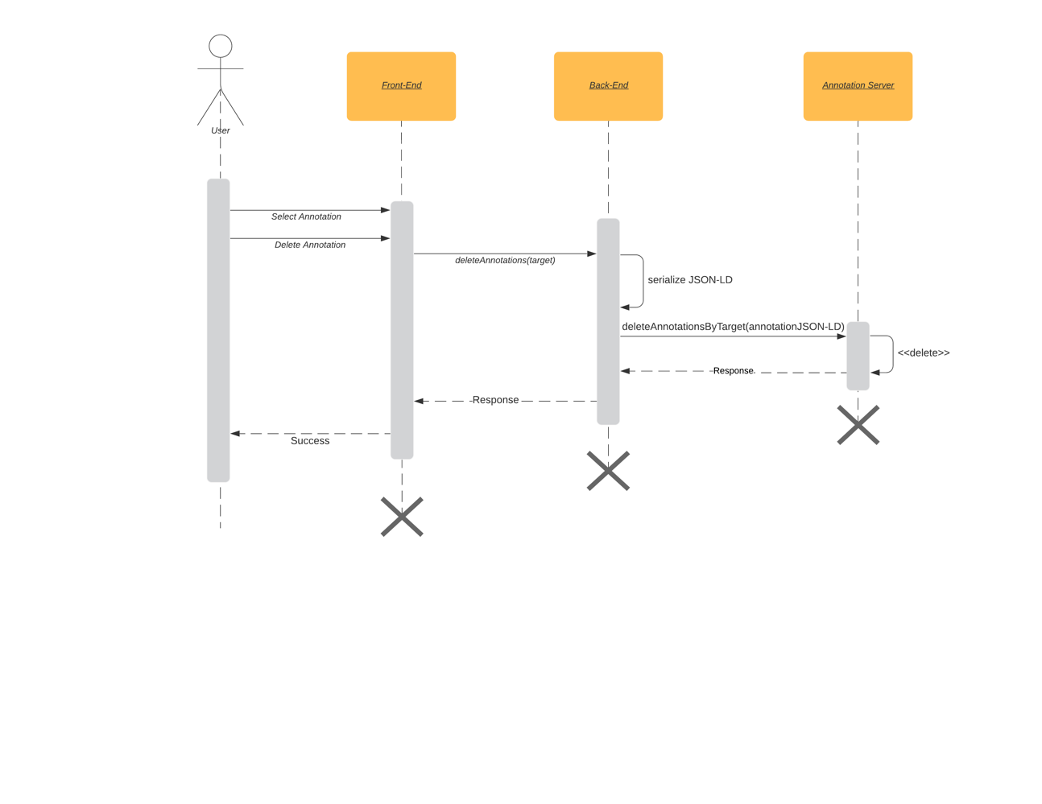

Figure 23 - Sequence Diagram for Delete Annotation

## Save Activity

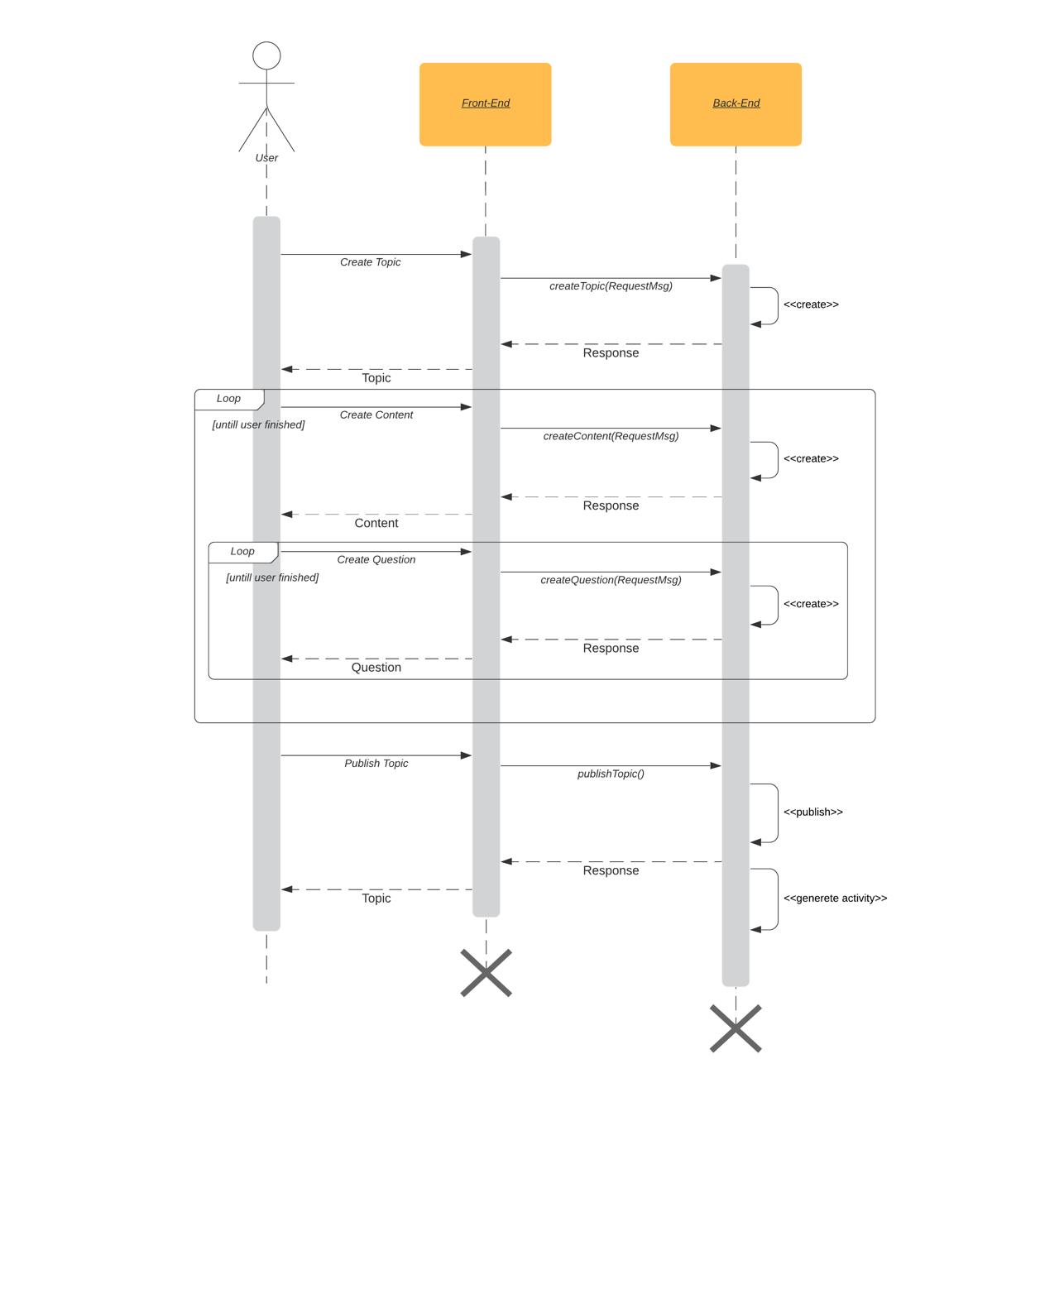

Figure 24 - Sequence Diagram for Save Activity

## Get Notifications

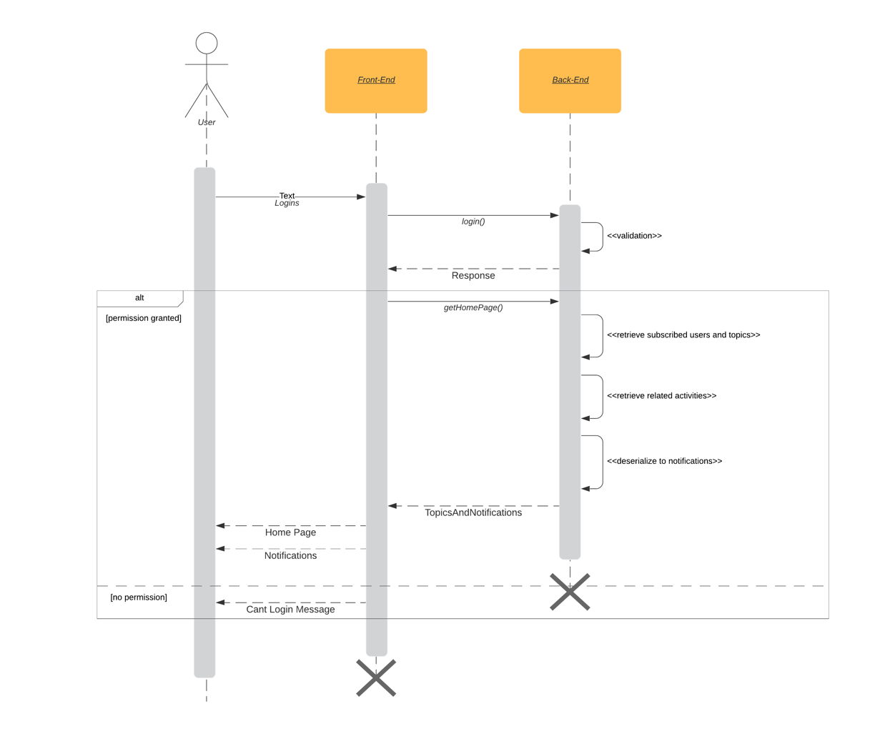

Figure 25 - Sequence Diagram for Get Notifications

## Get Recommendations

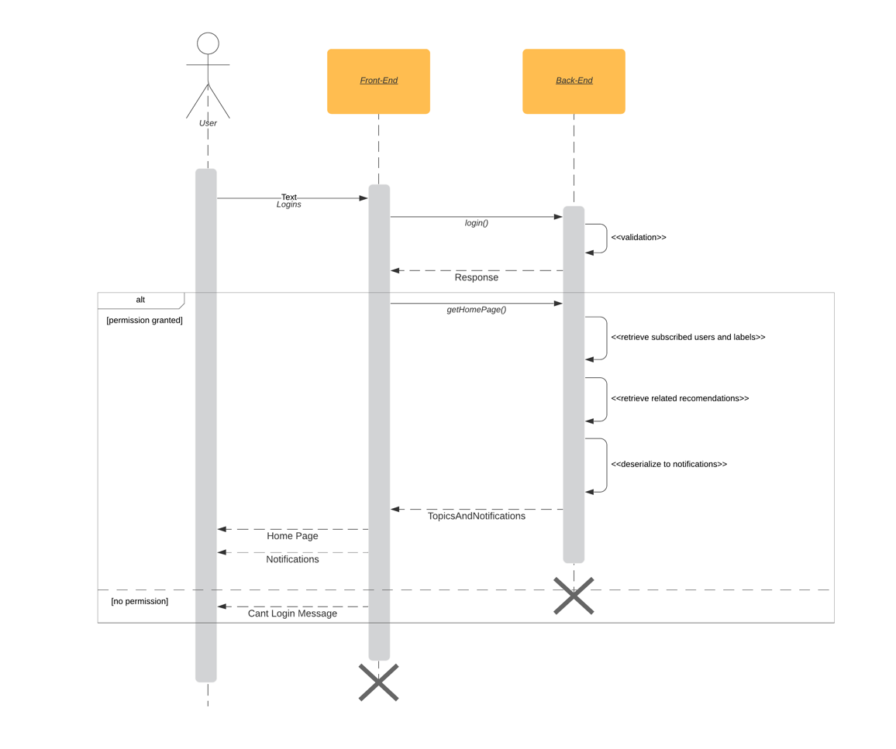

Figure 26 - Sequence Diagram for Get Recommendations

# ER Diagrams

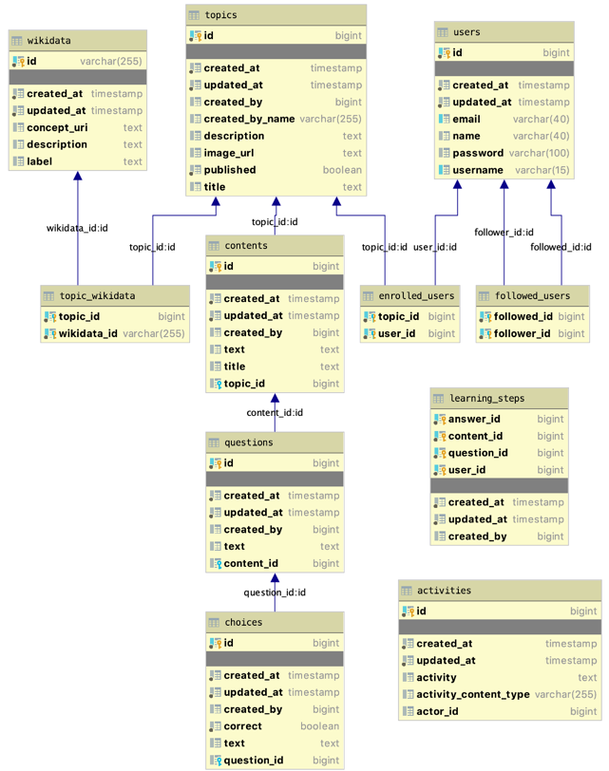

Figure 27 - Entity Diagram

# Class Diagrams

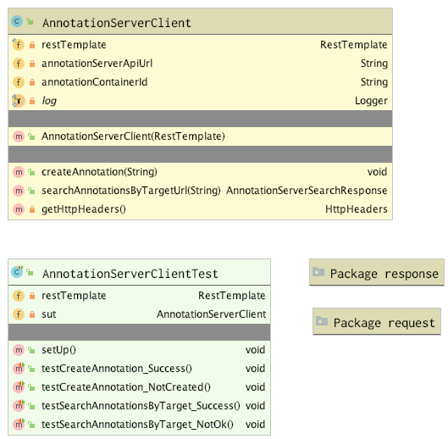

Figure 28 - client package

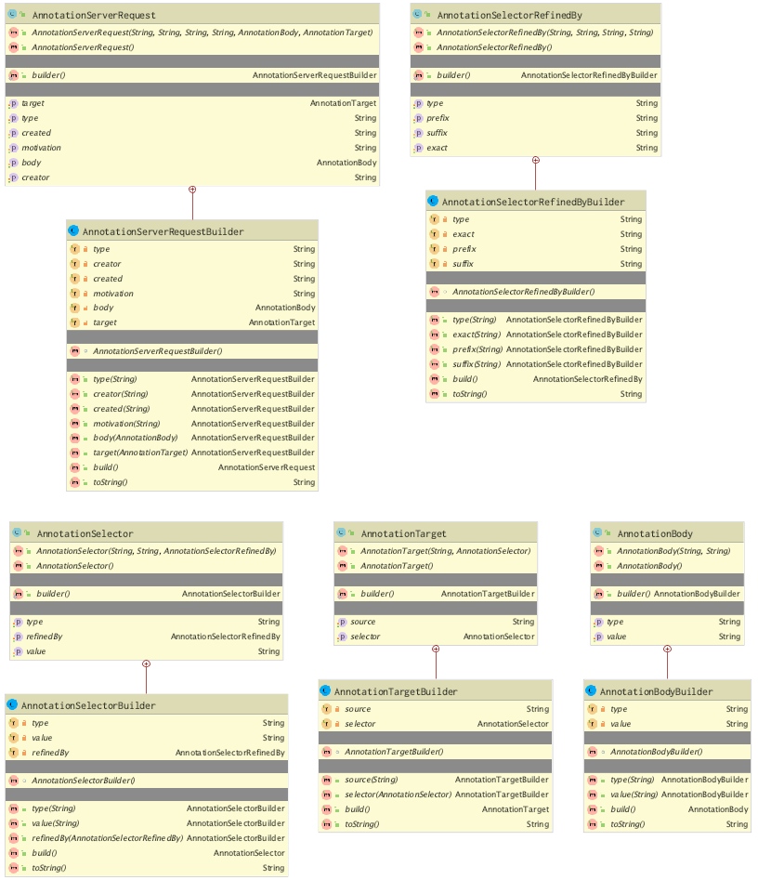

Figure 29 - client/request package

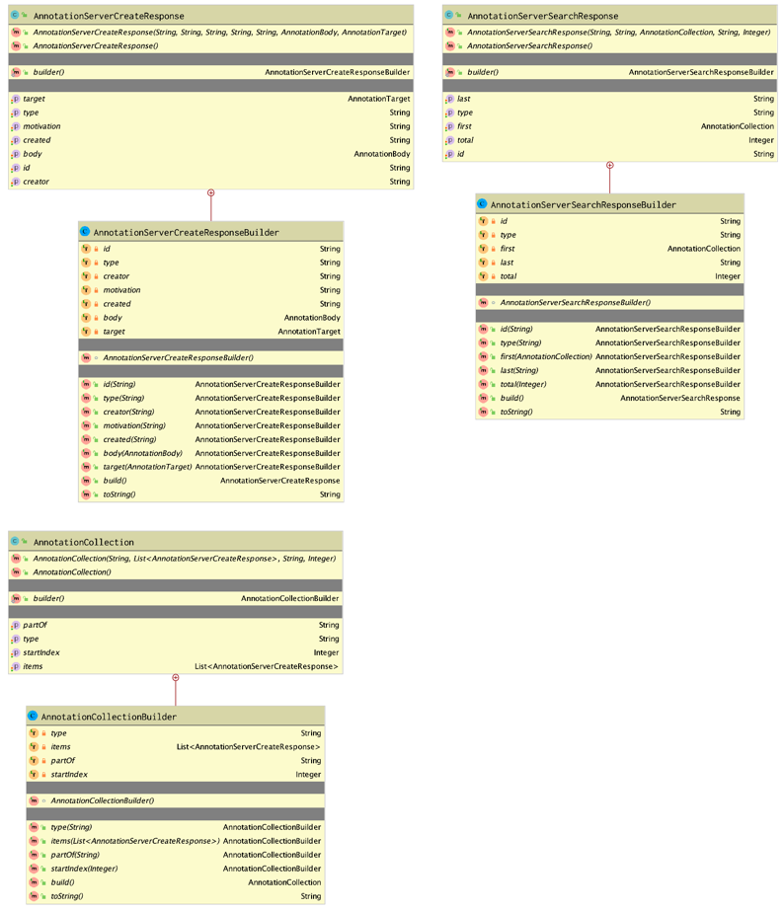

Figure 30 - client/response package

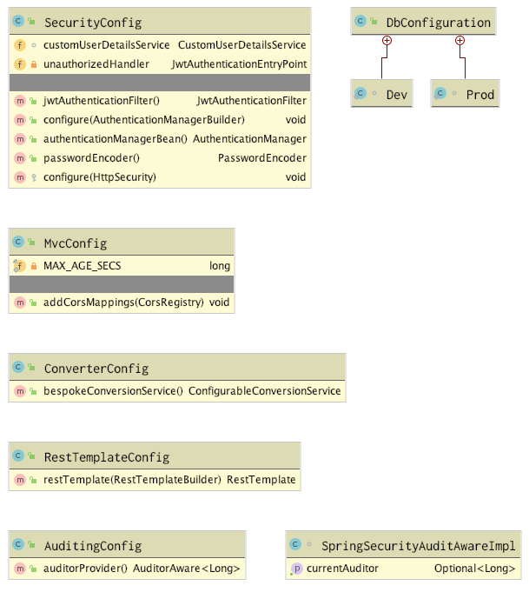

Figure 31 - config package

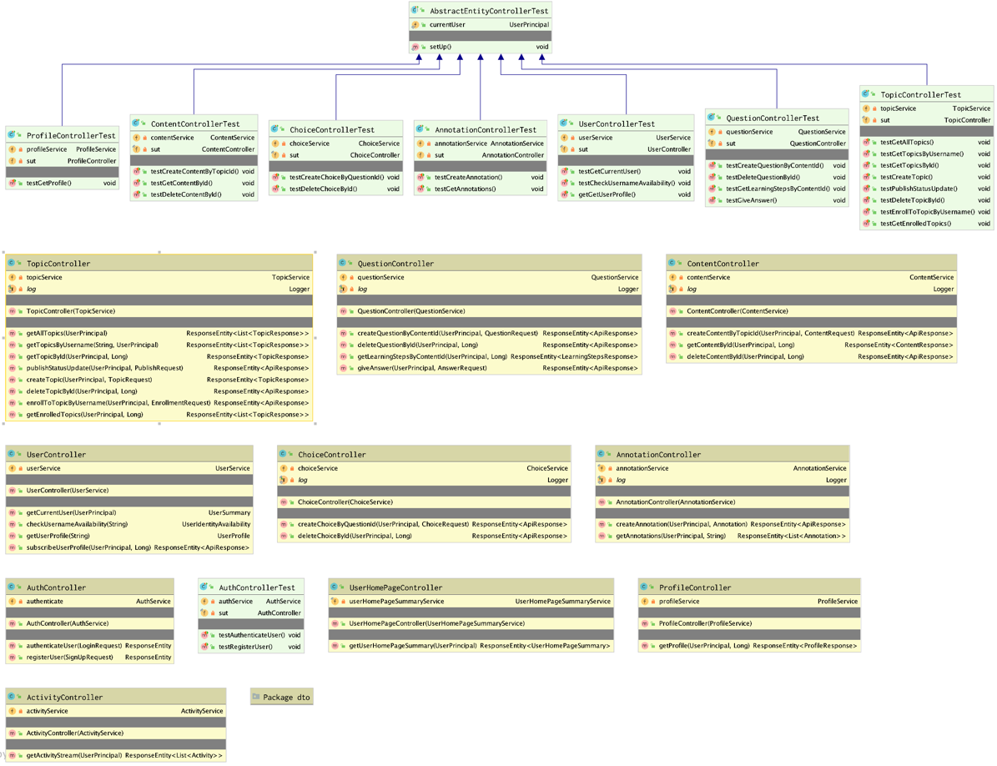

Figure 32 - controller package

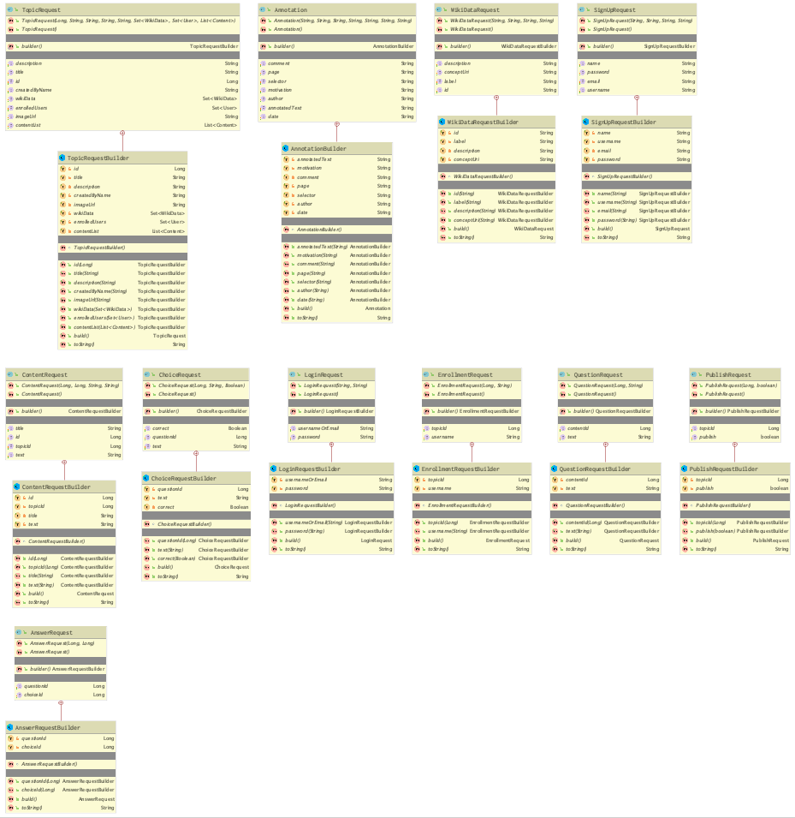

Figure 33 - controller/dto/request package

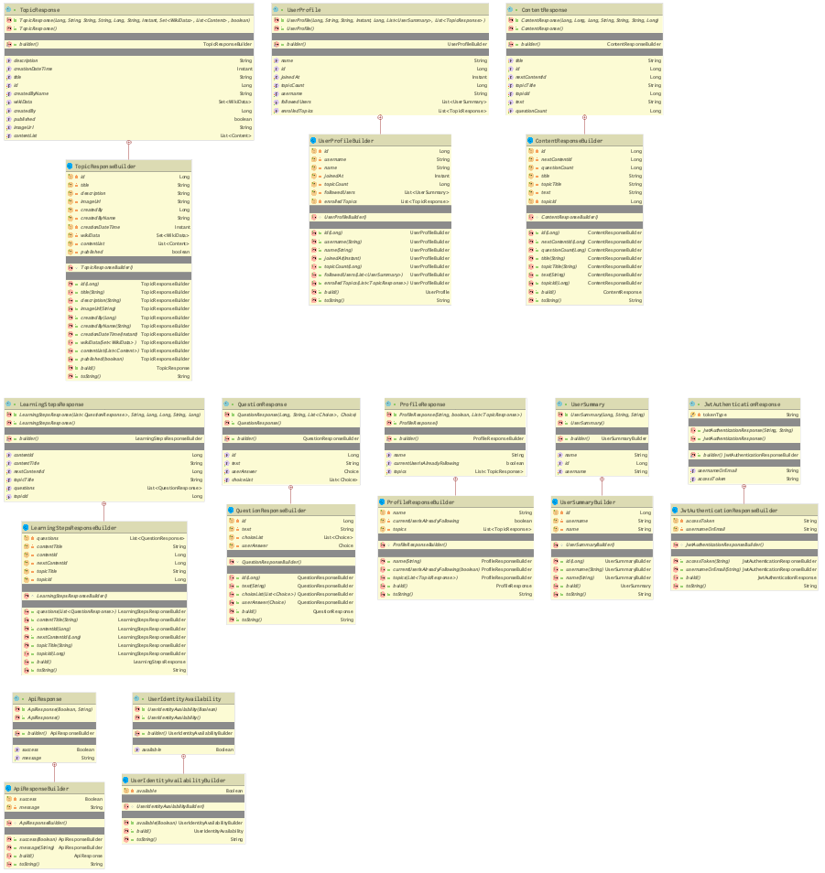

Figure 34 - controller/dto/response

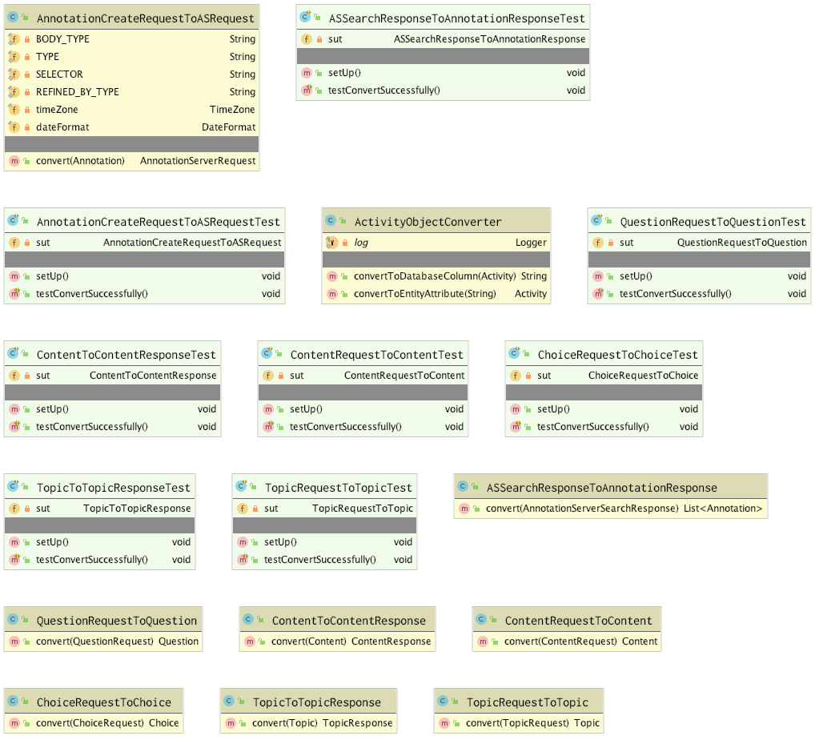

Figure 35 - converter package

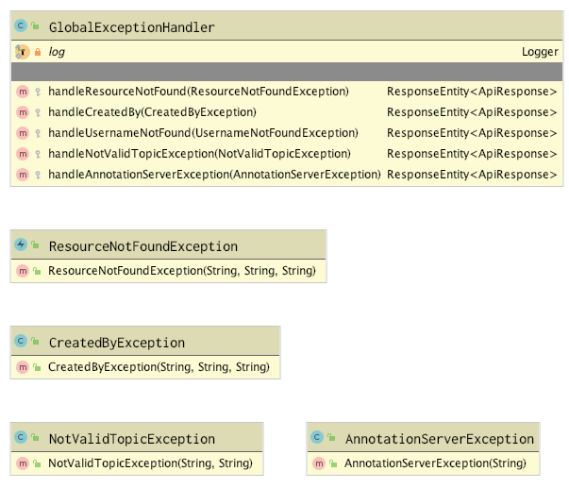

Figure 36 - exception package

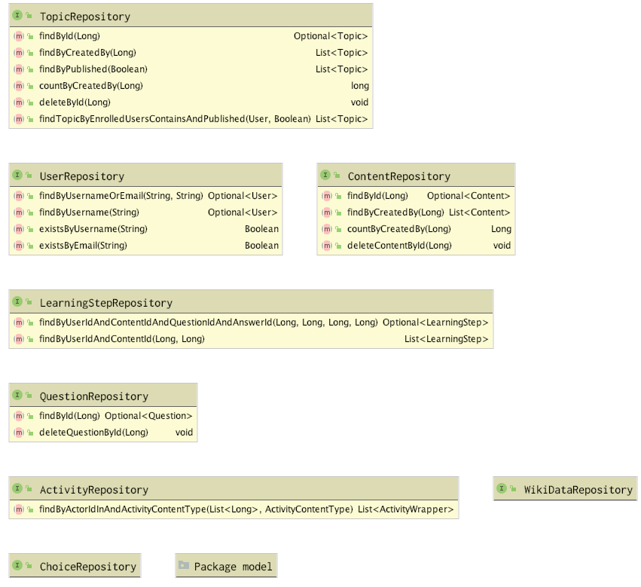

Figure 37 - persistence package

# 

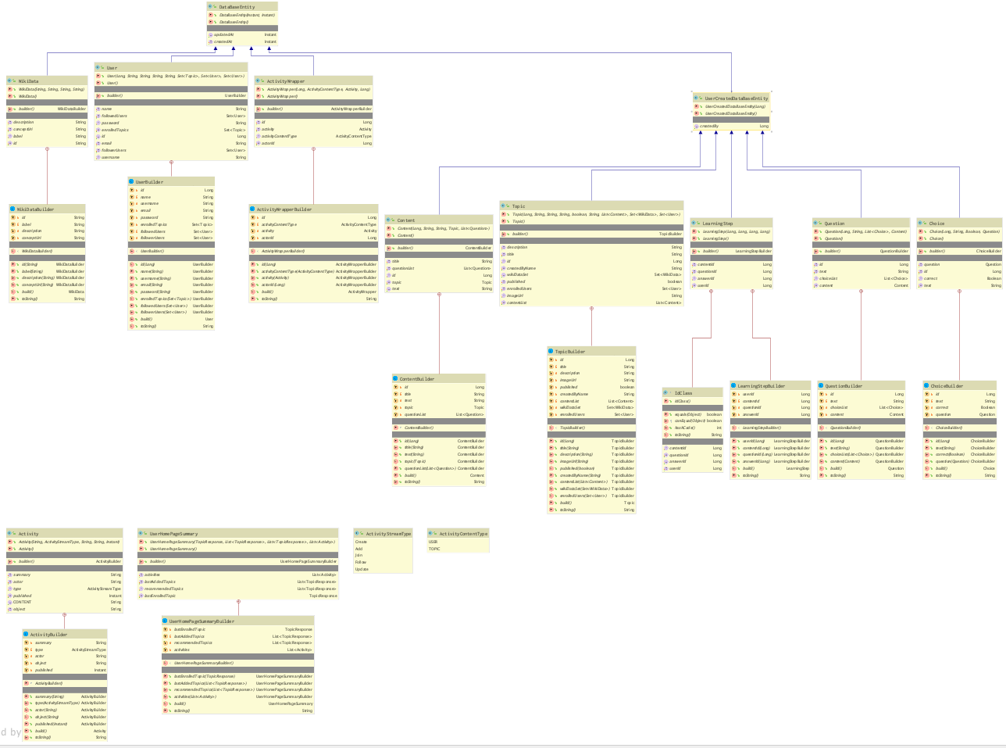

Figure 38 - persistence/model package

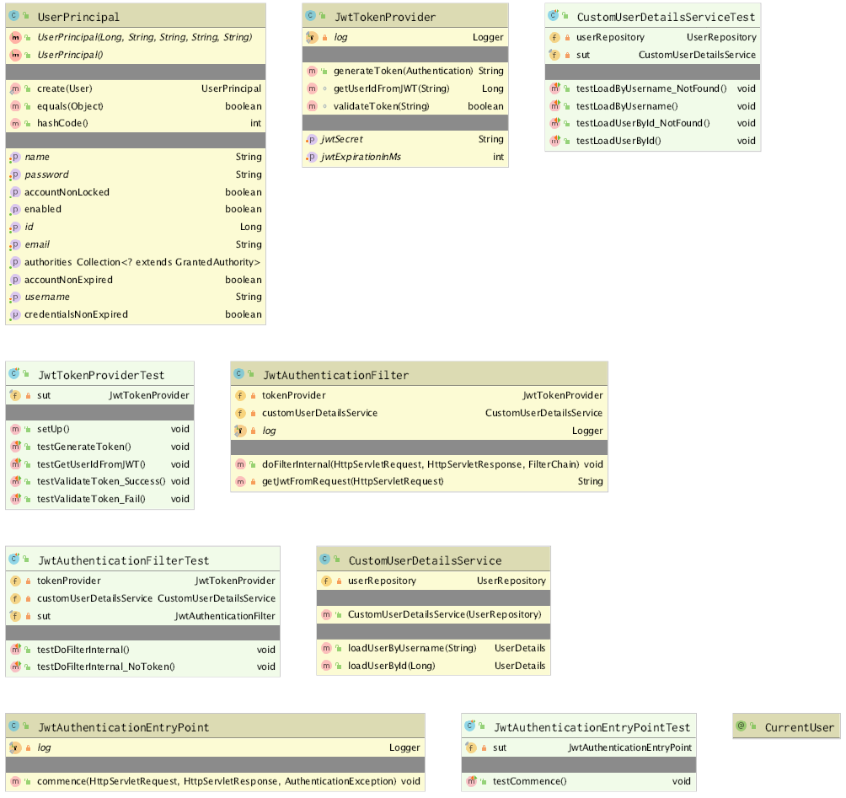

Figure 39 - security package

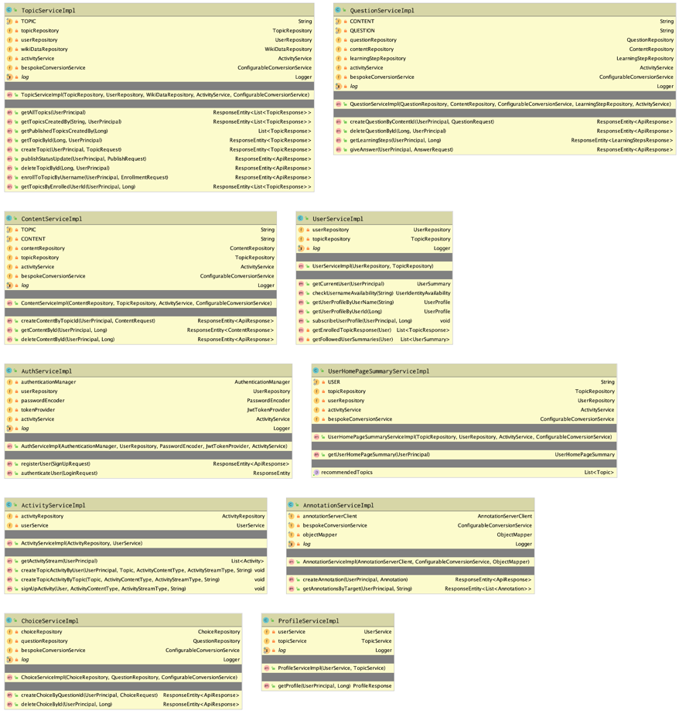

Figure 40 - service/implementation package

# Folder Structure

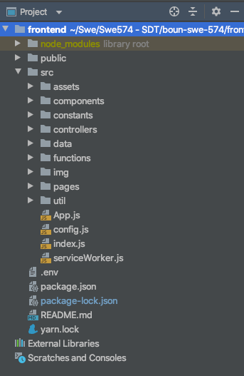

Figure 41 - Frontend Folder Structure

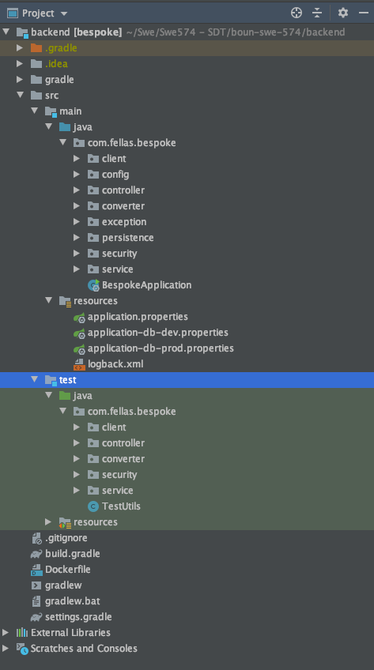

Figure 42 - Backend Folder Structure

# Conclusion

Spring Rest API architecture is used for Bespoke Web Application project. Frontend and Backend are designed as separate projects. Database entities are designed with Hibernate ORM. Amazon EC2 service is used as a cloud server and Amazon RDS selected as a database server.

Activity Streams are hardcoded by our own solution.

Elucidate Server is used for annotations as a third-party application.

We are thankfully for the project to give us a chance to examine a team experience.

# Appendix

## Research: Git and GitHub

**Git** is a free and open source distributed version control system. Can be downloaded from <https://git-scm.com/download/win>.

Version control is a system that records changes to a file or set of files over time so that we can recall specific versions later.

**GitHub** is a web-based Git repository hosting service, which offers all of the distributed revision control and source code management (SCM) functionality of Git as well as adding its own features such as issue tracking, labels, milestones and project management. <https://github.com/>

Especially we do not need GitHub to use Git. On the other hand GitHub is useful for code sharing and collaboration. Bitbucket, gitlab can also be the alternatives for GitHub. There are also gui tools to visualize version control workflow such as SourceTree. <https://www.sourcetreeapp.com/>

**Benefits of GitHub**

* Sharing our repositories.
* Accessing other user's repositories.
* Storing our local repositories in GitHub cloud as remote repository.

**Git Commands**

These commands can be used in the terminal after installing Git. For details please refer to documentation <https://git-scm.com/doc>.

git --version

git config --global user.name "John Doe"

git config --global user.email johndoe@example.com

git config --list

git init

git status

git add -A

git add .

git commit -m "message"

git push

git log

git clone

git branch

git merge

## Research: Rest

**Rest** stands for Representational state transfer. GET, PUT, POST, DELETE are used as verbs.

* Messages(payload): JSON/XML
* URI: Uniform resource identifier (a unique string identifying a resource)
* URL:Uniform resource locator(a URI with network identification - http://wwww.example.com
* Idempotence: Certain operation applied multiple times without changing the result. GET, PUT and DELETE are idempotence. POST is the only operation which is not idempotence.
* Stateless: Service does not maintain any client state.
* HATEOAS: Hypermedia As The Engine of Application. A rest client should then be able to use server-provided links dynamically to discover all the available actions and resources it needs. As access proceeds, the server responds with text that includes hyperlinks to other actions that are currently available.

**Richardson Maturity Model**

A model used to describe the maturity and quality of RESTful services.

There is no formal specification for REST.

**RMM Levels**

Level 3: Hypermedia Controls, makes API more self-documenting

Level 2: HTTP Verbs (most common)

Level 1: Resources

Level 0: The swap of POX (plain old XML)

**HTTP Request Methods**

GET, get information

POST, send information

PUT, update existing information

DELETE

**HTTP Status Codes**

100 - informational

200 - successful

300 - redirections

400 - client errors, bad request

500 - server errors

## Overview of Security Mechanism

* API to register new users with their full name, username, email and password.
* API to let users log in using their username/email and password. After validating the user's credentials, the API should generate JWT token and return the token in the response. The client will use that token in the Authentication header of all requests to access any protected resources.
* Configure Spring Security to restrict access to protected resources and also will throw 401 for unauthorized access.
* Configure Role-based Authorization to protect resources on the server.

## How To Use Postman with JWT Token

*Note: Postman v7.0.9 is used for the project.*

* Add accessToken variable to postman environmental variable.

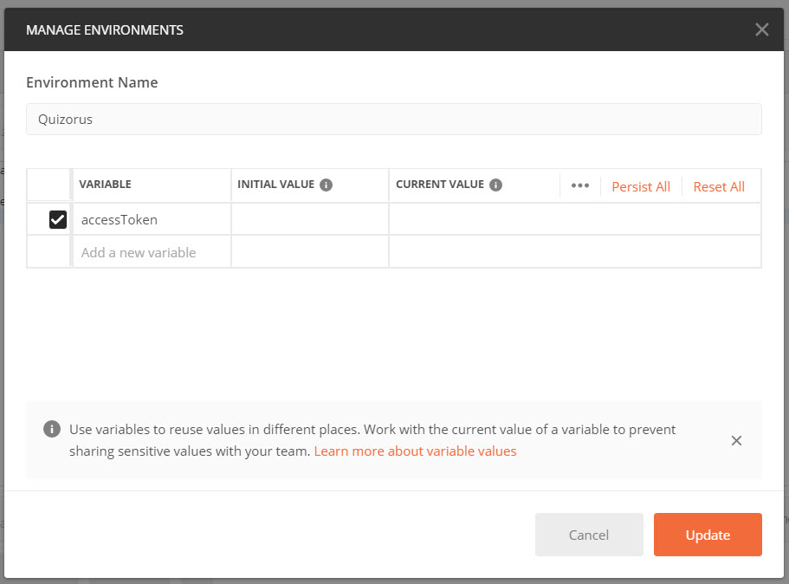

* Then use Tests tab to write javascript.

let jsonData = pm.response.json();

let token = jsonData.accessToken;

pm.environment.set('accessToken', token);

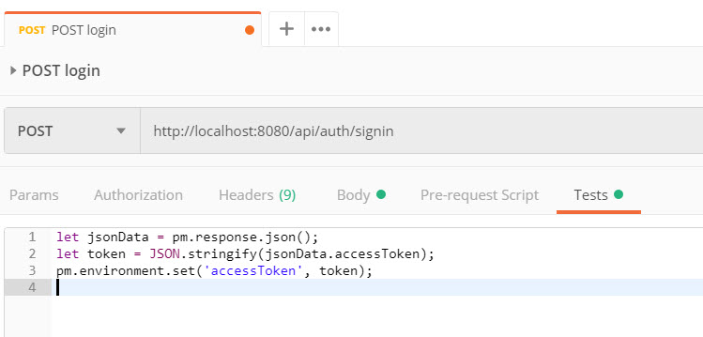

* If you are usign the current version "Bearer Token" type is under Authorization tab.

